NOTES

S8P4
STUDENT WILL INVESTIGATE RELATIONSHIP BETWEEN FORCE, MASS, AND THE MOTION OF OBJECTS

MOTION

MOTION IS THE STATE IN WHICH ONE OBJECT’S DISTANCE FROM ANOTHER IS CHANGING.


THE OBJECT OR POINT FROM WHICH MOVEMENT IS DETERMINED IS CALLED A FRAME OF REFERENCE.



MOVEMENT CAN BE MEASURED ONLY WITH REFERENCE TO SOMETHING THAT IS ASSUMED TO BE FIXED IN PLACE.



FOR THE SUNSET THE FRAME OF REFERENCE IS THE EARTH. IT IS THE EARTH THAT APPEARS TO STAY IN PLACE WHILE THE SUN MOVES.

WHAT IS THE FRAME OF REFERENCE FOR AN EARTHRISE?

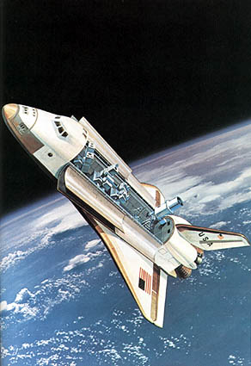

THE MOST COMMON FRAME OF REFERENCE IS THE EARTH’S SURFACE FOR DETERMINING POSITION AND MOTION.

Show this one
https://www.youtube.com/watch?v=21BwUNDOQno

MOTION GRAPHS

GRAPHS HELP MAKE MOTION EASIER TO PICTURE AND UNDERSTAND.

MOTION IS A CHANGE IN POSITION MEASURED BY DISTANCE AND TIME.

SPEED: TELLS US THE RATE AT WHICH AN OBJECT MOVES.

VELOCITY: TELLS US THE RATE OF SPEED AND THE DIRECTION OF MOVING OBJECTS.

ACCELERATION: TELLS US THE RATE, SPEED, AND THE CHANGES IN DIRECTION.

Distance: the measure between two points.
DISPLACEMENT: The overall change of position.

When displacement has a direction it is called a vector.

Vectors are used in science to describe anything that has both a direction and a magnitude.

The ball's velocity vector describes its movement—the direction of the vector arrow marks the ball's direction of motion, and the length of the vector represents the speed of the ball.

When distance does not have a direction it is called a scalar.

A scalar is a quantity that is fully described by a magnitude only.

Speed, Velocity, and Acceleration
https://www.youtube.com/watch?v=apewLkLAR-U

Magnitude defines the size of an entity, or its speed when moving, in comparison to motion.

- In physics, magnitude is described in simple words as “distance or quantity”.
- It shows the direction or size that is absolute or relative in which an object moves in the sense of motion.
- It is used to describe the size or extent of something.
- Generally, in physics, magnitude relates to distance or quantity. Magnitude defines the size of an entity, or its speed when moving, in comparison to motion.

The line from the starting point to the ending point is called displacement.

Suppose Alexia jogs to the 50-m mark and then turns around and runs back to the 20-m mark.

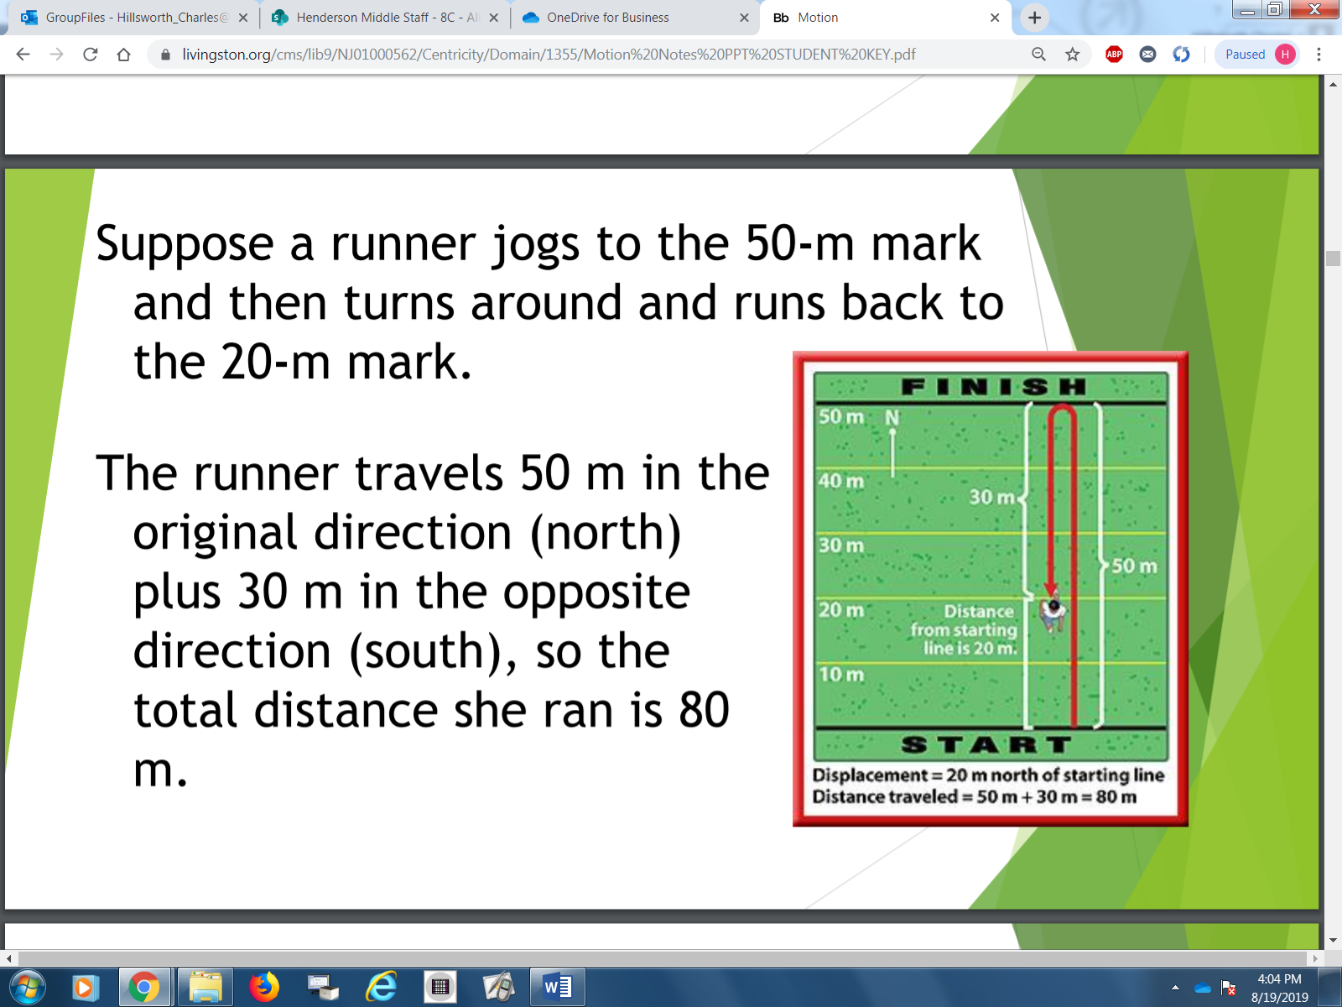

Rules for Displacement

1. Add displacements in the same
direction
2. Subtract displacements in opposite
directions

3. Displacements that are not in the same
or opposite directions cannot be
directly added together.

ADDING DISPLACEMENTS

2 M + 3M = 5M

Suppose a runner on La Vista road runs 15m east, stops at the crosswalk at Henderson road, and then continues to run along La Vista Rd for another 5m. His displacement is:

15m east + 5m east = 20m east

Suppose a runner walks 25m east, turns around, and walks 5m west. The size of the displacement is:

25m east – 5m west = 20m

SUPPOSE A RUNNER STARTS AT “A” RUN 3M North, the 5m east, then 3 meters south, then 5m
west, what is his displacement? What is the distance covered?

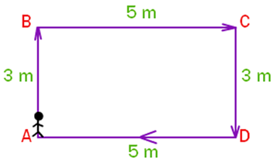

Zero

https://www.youtube.com/watch?v=V8hJhTE3bUk

Rihana rides 4m northeast on her bike (A-B) and then 3m east (B-C). Rihana rides a total distance of 7m, but the displacement is 5m in a NNE direction. How is that solved? Here is where the Pythagorean theorem is used:

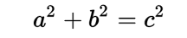

The displacement cannot be added or subtracted so rule 3 applies because the displacements are not in the same direction or opposite directions.

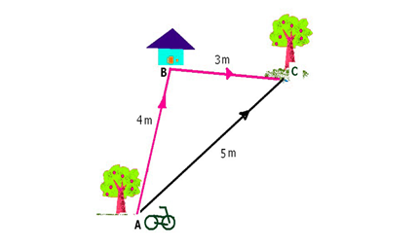

a²+ b² = c² is used

DISTANCE-TIME GRAPHS

DISTANCE-TIME GRAPHS OR DISPLACEMENT-TIME GRAPHS ARE REPRESENTED BY PICTURES FOR OUR INTERPRETATION OF THE GIVEN DATA.

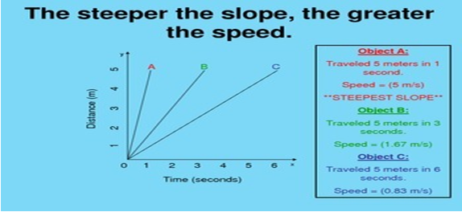

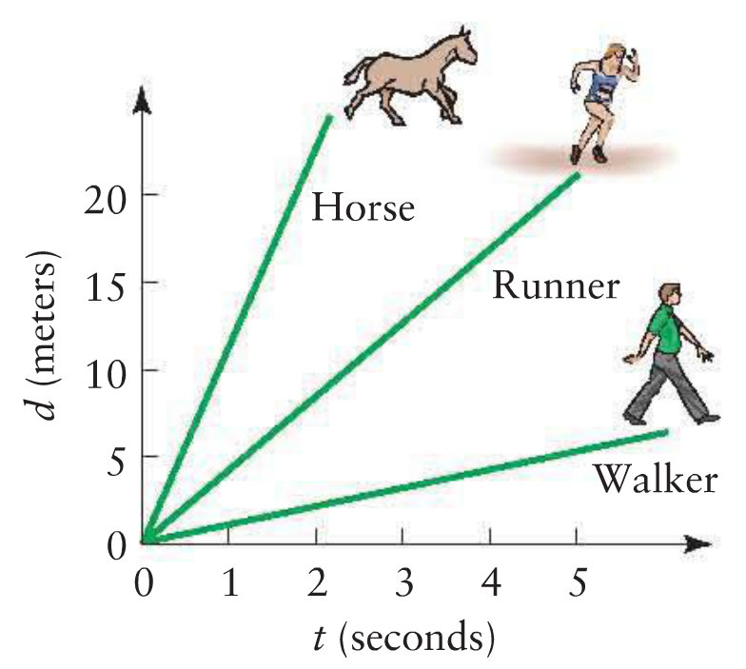

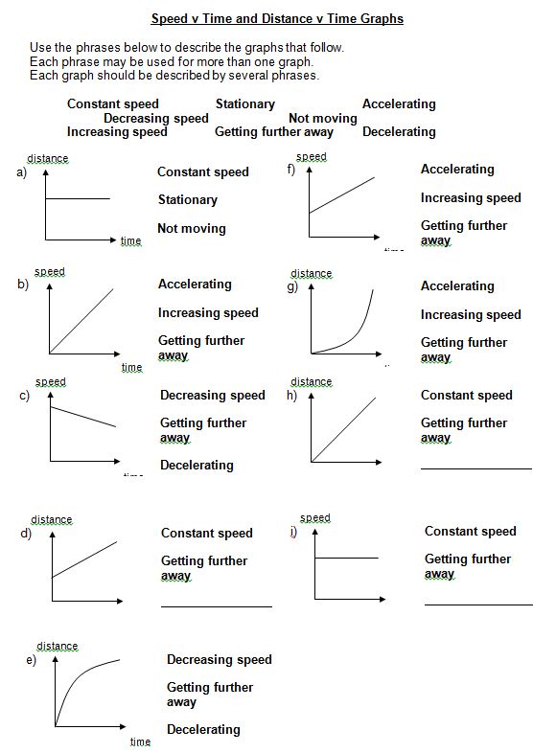

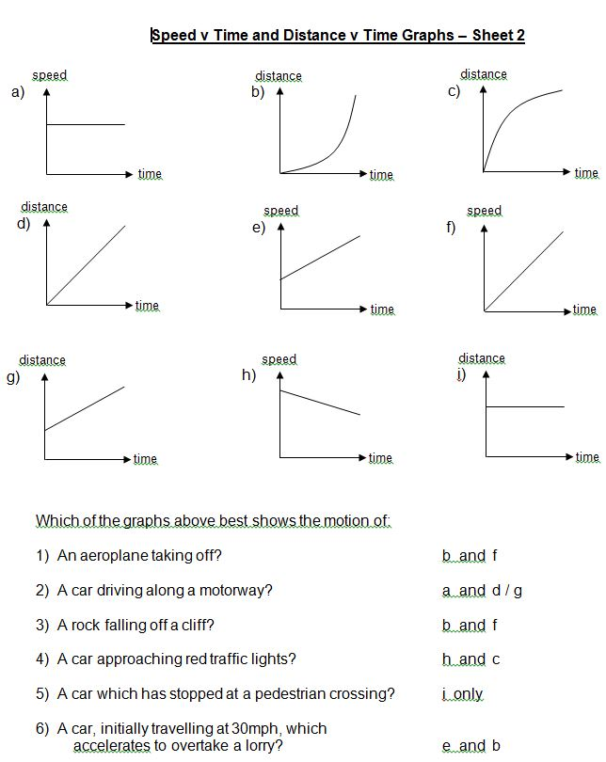
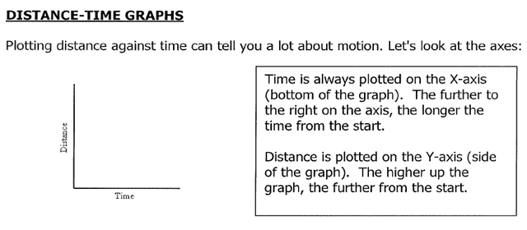

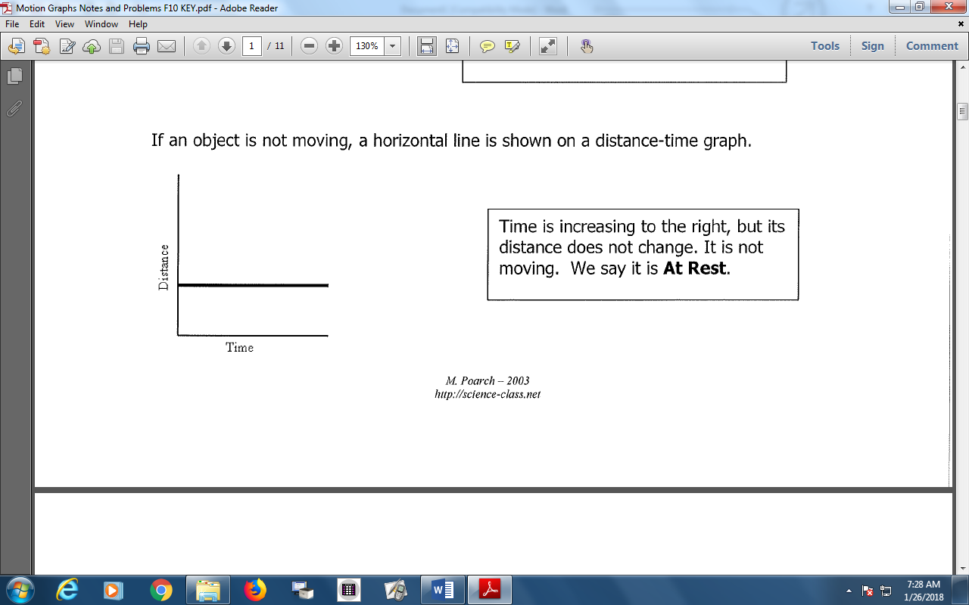

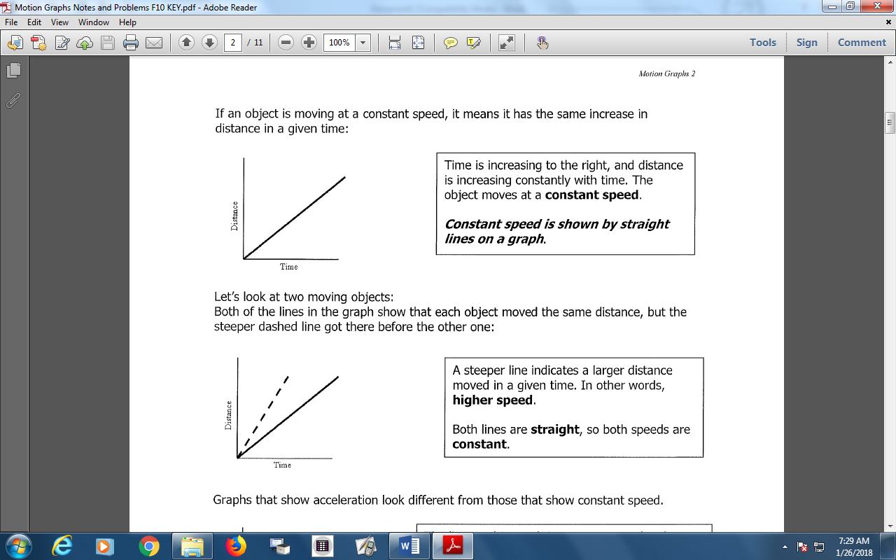

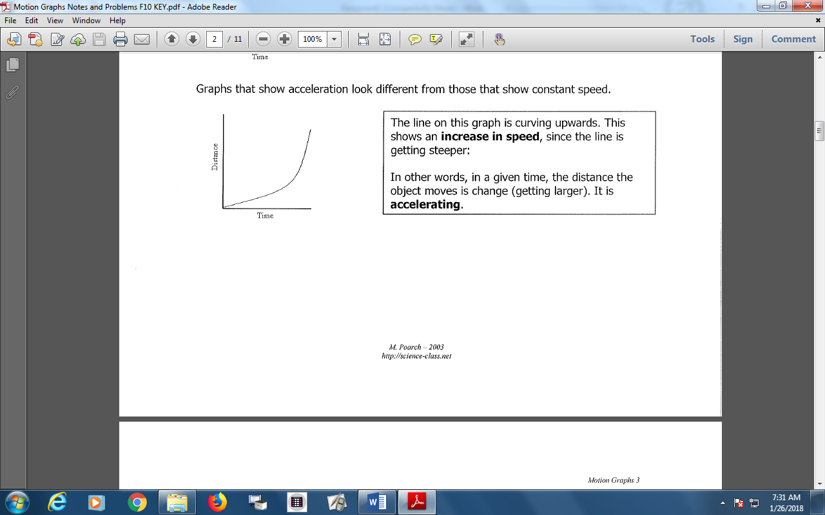

Video on distance vs Time Graph
https://www.youtube.com/watch?v=l93-BkAJ3UY

Speed vs Time Graph
https://www.youtube.com/watch?v=yJkyzzBryEM

Show these:
https://www.youtube.com/watch?v=s7gIqkOUQCM
https://www.youtube.com/watch?v=LJctqrA9jhU

https://www.youtube.com/watch?v=LJctqrA9jhU

https://www.youtube.com/watch?v=LJctqrA9jhU
https://www.youtube.com/watch?v=_MLH-9W0oxQ

Speed distance
https://www.youtube.com/watch?v=5TkO__sNwiI
https://www.youtube.com/watch?v=DkCw2C-DkT0

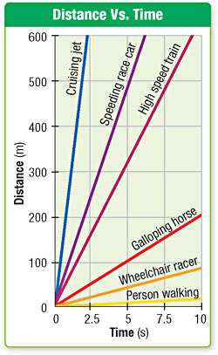

When an object’s motion is graphed by plotting distance on the y-axis and time on the x-axis, the slope of the graph is speed.

a) Which line has the greatest speed?
b) Which line has the least slope?

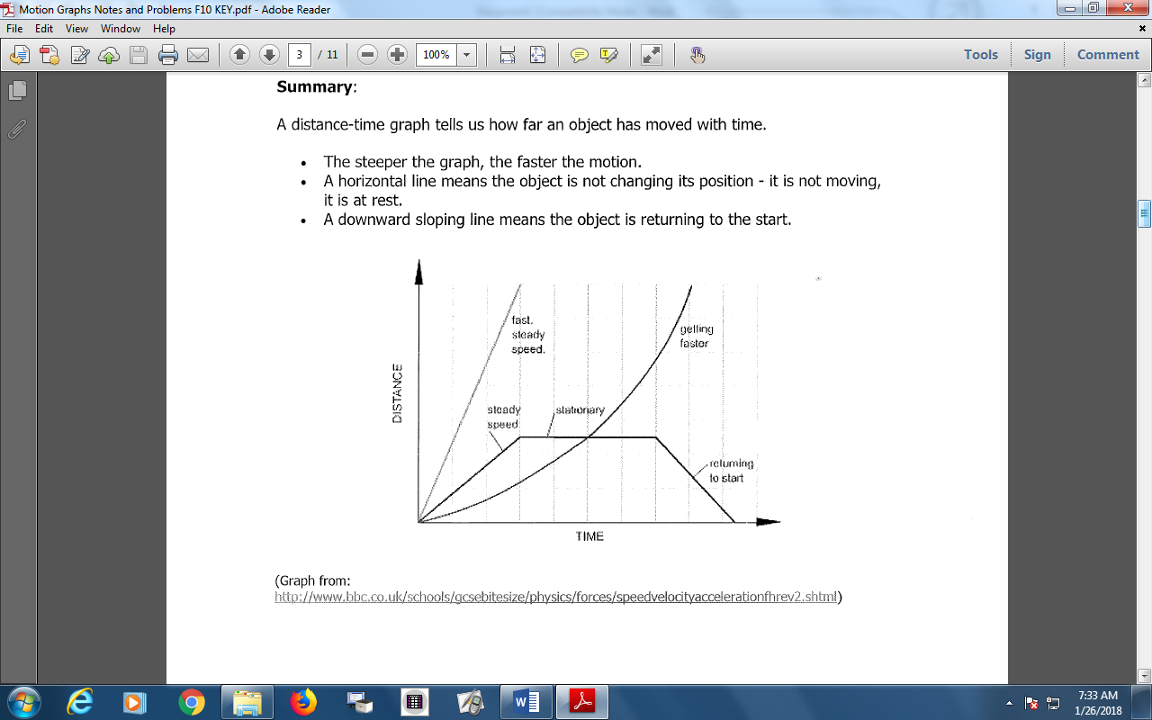
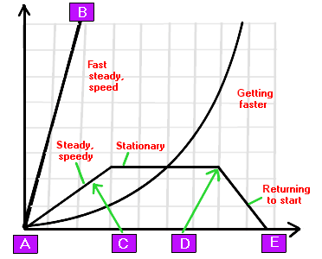
• A distance-time graph tells us how far the object moved with time.
• The steeper the graph, the faster the motion.
• A horizontal line means the object is not changing its position that means it is not moving.
• A downward sloping line means the object is returning to its initial position.

Speed-Time Graph
Back to Top
In the above speed time graph or the velocity time graphs, speed or velocity of the object is generally plotted on the y direction and the time is plotted in the x direction.
In the graph, a Horizontal line denotes that speed is constant and is not changing over time. Here the object is moving with constant speed.
The steepness in the graph shows the increasing speed which means the object is accelerating.
The third picture denotes the decreasing speed which means the object is decelerating.

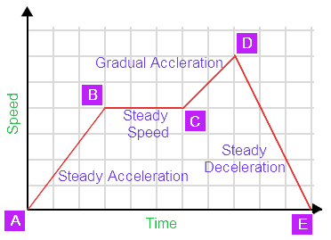

Acceleration-Time Graph
Back to Top
In the acceleration time graph, acceleration of the object is generally plotted on the y direction and the time is plotted in the x direction.
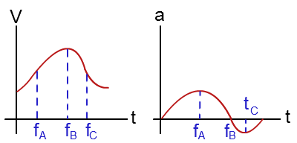

Interpreting (Acceleration - Time Graph (A-T Graph))

In the figure, it is explained that how the acceleration time graph can be obtained from the Velocity time graph. At any point in the velocity time graph acceleration at that point can be defined as the slope at that point.
Positive value of the acceleration in the acceleration time graph shows that velocity in increasing and it is increasing in the positive direction.

Negative value of the acceleration shows that the velocity is decreasing and it is decreasing in the negative direction. Acceleration goes zero when the slope in the velocity time graph becomes zero. The slope in the velocity time graph becomes zero when the velocity becomes maximum and reaches at its peak point.

SPEED & VELOCITY

MOTION IS A CHANGE IN POSITION RELATIVE TO A FRAME OF REFERENCE.



THE MOTION OF THE RUNNERS WAS MEASURED RELATIVE TO THE STARTING BLOCKS.

MOTION IS MEASURED BY DISTANCE AND TIME.

SPEED AND VELOCITY

SPEED IS THE RATE AT WHICH AN OBJECT MOVES.

SPEED IS THE DISTANCE TRAVELLED BY A MOVING OBJECT PER UNIT OF TIME.

SPEED = DISTANCE
_____________________________
TIME

EX. 1. A CAR TRAVELS 300 km IN 6
HOURS. WHAT IS THE SPEED
OF THE CAR?

EX. 2. WHAT IS THE SPEED OF A JET
PLANE THAT FLIES 7200 km IN
9 HOURS?

SPEED THAT DOES NOT CHANGE IS CALLED CONSTANT SPEED.

THE SPEED OF A MOVING OBJECT IS NOT ALWAYS CONSTANT.

DIVIDING THE TOTAL DISTANCE BY THE TOTAL TIME GIVES THE AVERAGE SPEED.

VELOCITY

VELOCITY IS THE SPEED OF AN OBJECT IN A PARTICULAR DIRECTION.

VELOCITY CHANGES AS SPEED OR DIRECTION CHANGES.

AN OBJECT’S VELOCITY IS CONSTANT ONLY IF ITS SPEED AND DIRECTION DO NOT CHANGE.

CONSTANT VELOCITY IS ALWAYS ALONG A STRAIGHT LINE.

AN OBJECT’S VELOCITY WILL CHANGE IF EITHER ITS SPEED OR DIRECTION CHANGES.

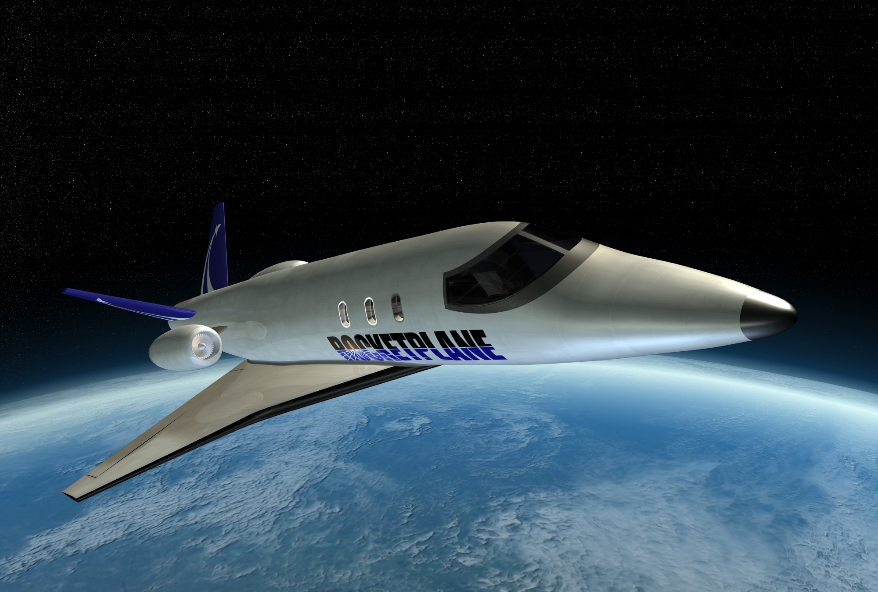

IF A JET TRAVELING AT 455 km/s SOUTH SPEEDS UP TO 620 km/s, A CHANGE IN VELOCITY HAS OCCURRED.

A CHANGE IN VELOCITY ALSO OCCURS IF THE JET CONTINUES TO TRAVEL AT THE SAME SPEED BUT CHANGES DIRECTION TO THE EAST.

ACCELERATION

ACCELERATION IS THE RATE AT WHICH VELOCITY CHANGES.

IT IS ALSO HOW FAST VELOCITY CHANGES.



NEWTON’S SECOND LAW OF MOTION

THE NET FORCE ON AN OBJECT IS EQUAL TO THE PRODUCT OF ITS ACCELERATION AND ITS MASS.

THE RELATIONSHIP OF FORCE, MASS, AND ACCELERATION CAN BE WRITTEN AS AN EQUATION.

FORCE = MASS X ACCELERATION

- FORCE IS MEASURED IN KILOGRAMS X METERS PER SECOND (kg.m/s²)

- MASS IS MEASURED IN KILOGRAMS (kg)

- ACCELERATION IS MEASURED IN METERS PER SECOND (m/s²)

THIS LONG UNIT (kg.m/s²) IS CALLED THE NEWTON.

ONE NEWTON EQUALS THE FORCE REQUIRED TO ACCELERATE ONE KILOGRAM OF MASS AT 1 METER PER SECOND PER SECOND.

1N = 1kg X 1m/s²

ACCELERATION = FORCE
___________________
MASS

EX 1. A 52 kg WATER-SKIER IS BEING PULLED BY A SPEEDBOAT. THE FORCE CAUSES HER TO ACCELERATE AT 2 m/s². CALCULATE THE NET FORCE THAT CAUSES THIS ACCELERATION.

EX. 2 WHAT IS THE NET FORCE NEEDED TO ACCELERATE A 25-kg CRATE OF BANANAS AT THE RATE OF 1.5 m/s²?

CALCULATING AVERAGE ACCELERATION

ACCELERATION REFERS TO INCREASING SPEED, DECREASING SPEED OR CHANGING DIRECTION



Acceleration = Final velocity-starting velocity divided by time it takes to change velocity.

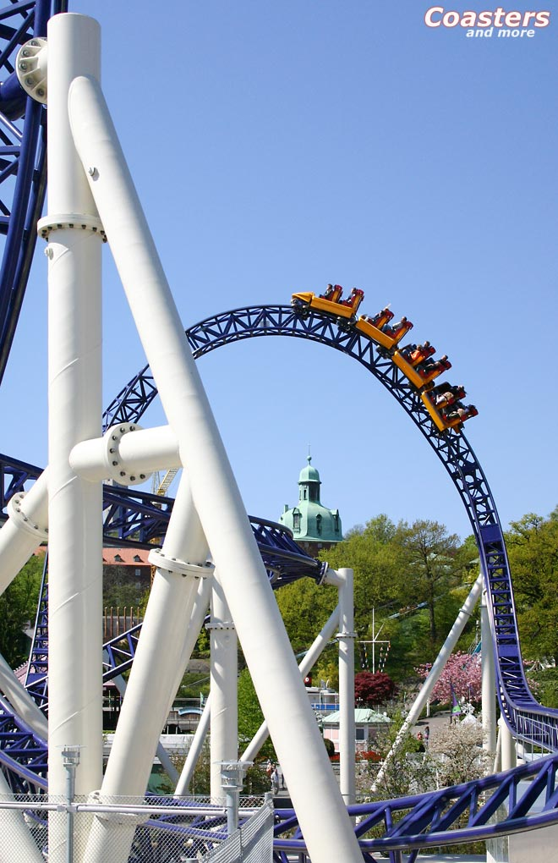

EX. A ROLLER COASTER’S VELOCITY AT THE TOP OF A HILL IS 10 km/h. TWO SECONDS LATER IT REACHES THE BOTTOM OF THE HILL WITH A VELOCITY OF 26 km/h. WHAT IS THE ACCELERATION OF THE ROLLER COASTER?

ACC.= Final Velocity – Original Velocity
_________________________________________________________________________________
Time
ACC. = V_{f} – V_{o}
_________________
t
ACC. = 26 km/h – 10 km/h
__________________________________________
2 s
ACC. = 16 km/h
_______________
2 s
ACC. = 8 (km/h)/s

t = V_{f} – V_{i} /a

V_{f} = (a x t) + V_{i}

V_{i} = V_{f} – (a x t)

TRY THIS

A CAR ADVERTISEMENT STATES THAT A CERTAIN CAR CAN ACCELERATE FROM REST TO 90 km/h IN 9 SECONDS. WHAT IS THE CAR’S AVERAGE ACCELERATION?
A DECREASE IN VELOCITY IS CALLED DECELERATION.

DECELERATION IS SOMETIMES CALLED NEGATIVE ACCELERATION.

