ELECTROMAGNETIC WAVES
https://www.youtube.com/watch?v=lwfJPc-rSXw
https://www.youtube.com/watch?v=QW5zeVy8aE0

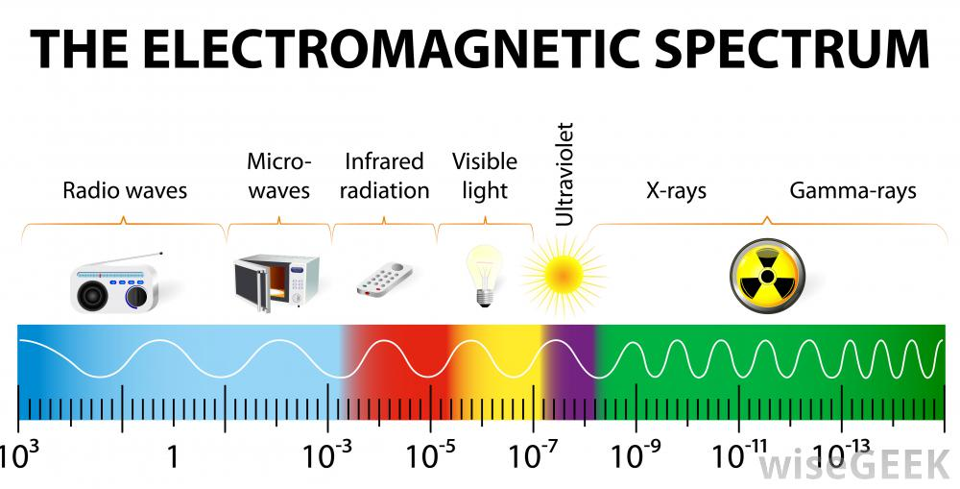

ELECTROMAGNETIC WAVE IS A WAVE THAT CAN TRAVEL THROUGH EMPTY SPACE OR THROUGH MATTER AND IS PRODUCED BY CHARGED PARTICLES THAT ARE MOVING.

THIS WAVE IS MADE UP OF TWO PARTS:

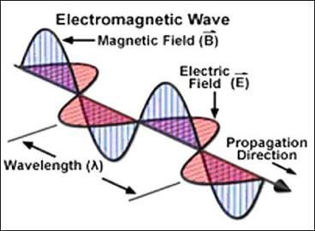

AN ELECTRIC FIELD
ATOMS CONTAIN PROTONS, NEUTRONS, AND ELECTRONS. PROTONS AND ELECTRONS HAVE A PROPERTY CALLED ELECTRIC CHARGE. THE ELECTRIC FIELD IS A FORCE FIELD THAT EXERTS A FORCE.

A MAGNETIC FIELD
MAGNETS REPEL OR ATTRACT. THEY ARE SURROUNDED BY A FORCE FIELD

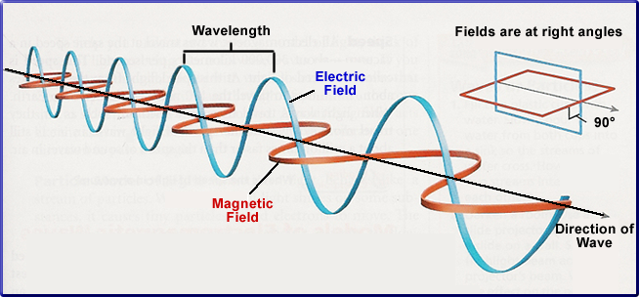

THE ENERGY CARRIED BY AN EM-W IS CALLED RADIANT ENERGY.

ALL EM-W TRAVEL THROUGH SPACE AT THE SPEED OF 300,000 Km/s

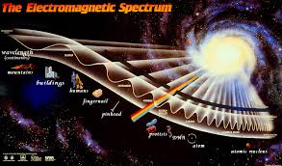
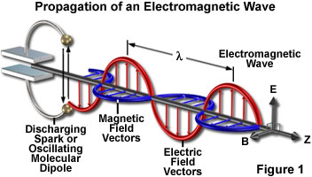

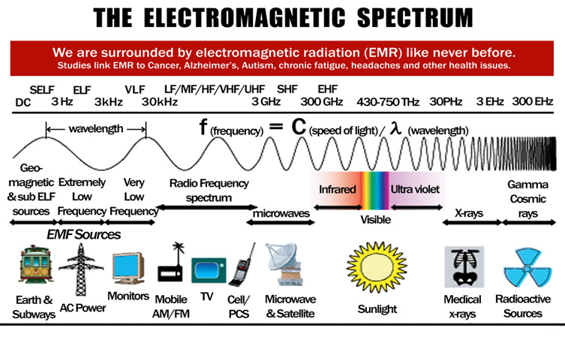

THE WIDE RANGE

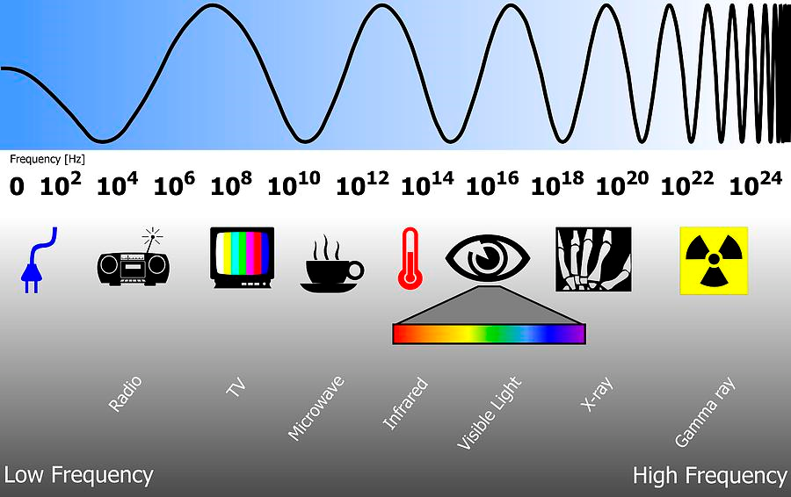

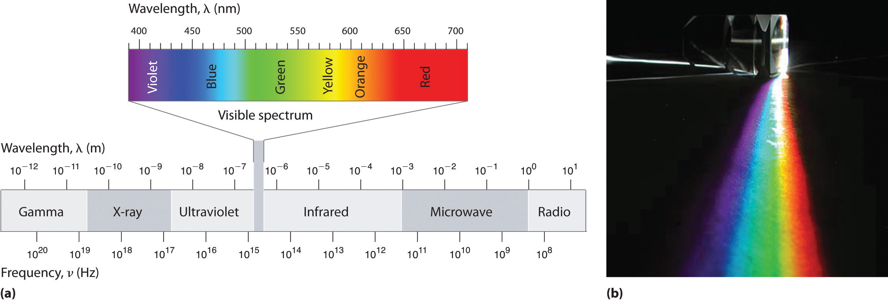

These waves are transverse in nature

Visible light
Wavelength of the different colors of the spectrum:
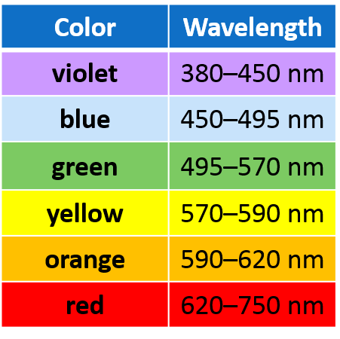

IN THE VISIBLE SPECTRUM OF COLORS THE SHORTEST WAVELENGTH IS VIOLET.

SHORTER WAVELENGTH IMPLIES HIGHER FREQUENCY AND THUS HIGHER ENERGY.

Violet is right before ultraviolet on the spectrum.

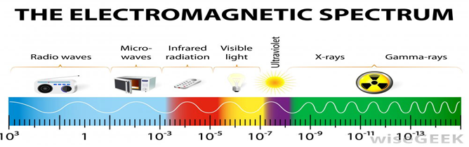

Violet is the color with the shortest wavelength.
The visible colors from shortest to longest wavelength are:
violet, indigo, blue, cyan, green, yellow, orange, and red.

Violet has the highest frequency and the shortest wavelength of the visible colors of light.
Red has the lowest frequency and the longest wavelength of the visible colors of light.

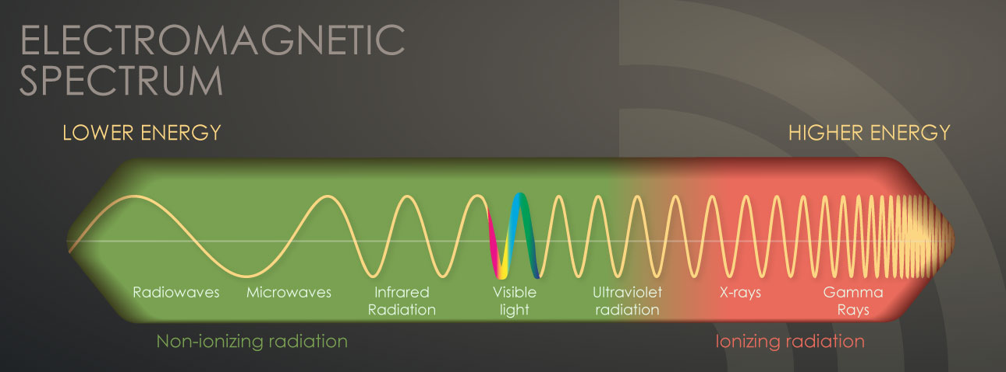
Electromagnetic Spectrum

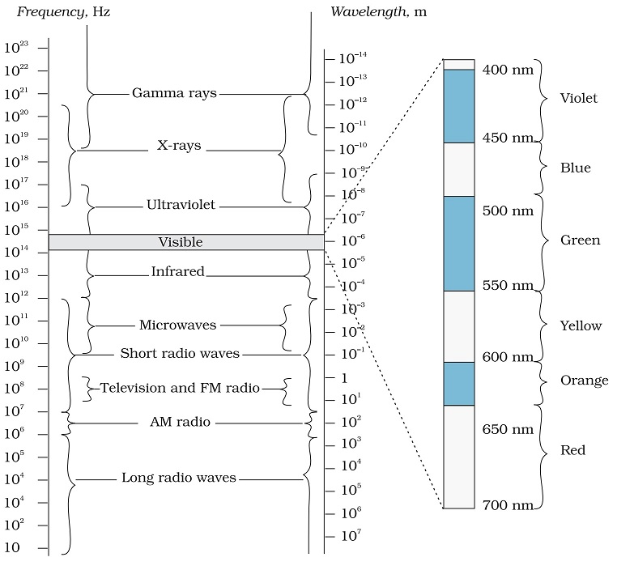

The electromagnetic spectrum includes, from longest wavelength to shortest: radio waves, microwaves, infrared, optical, ultraviolet, X-rays, and gamma-rays.

The wavelength and frequency of light are closely related. The higher the frequency, the shorter the wavelength.

Because all light waves move through a vacuum at the same speed, the number of wave crests passing by a given point in one second depends on the wavelength.

All the transverse electromagnetic waves in vacuum have the same speed of ≈3⋅108m/s.

Red light has a lower frequency and longer wavelength, while violet light has a higher frequency and shorter wavelength.

Red light entering glass is broken less than violet light.

When white light passes from air into a glass prism, violet bends the most and red bends the least. The other colors are bent by an amount between violet and red. When the light exits the prism, the light is separated into the colors in the visible spectrum.

Radio waves have the longest wavelengths in the electromagnetic spectrum. They range from the length of a football to larger than our planet. Heinrich Hertz proved the existence of radio waves in the late 1880s.

https://science.nasa.gov/ems/12_gammarays
https://science.nasa.gov/ems/11_xrays
https://science.nasa.gov/ems/10_ultravioletwaves
https://science.nasa.gov/ems/09_visiblelight
https://science.nasa.gov/ems/07_infraredwaves
https://science.nasa.gov/ems/06_microwaves
https://science.nasa.gov/ems/05_radiowaves
https://science.nasa.gov/ems/03_behaviors
https://science.nasa.gov/ems/02_anatomy
https://science.nasa.gov/ems/01_intro

Different Types of Electromagnetic Waves

Type (Wavelength) | Production | Detection
Radio (> 0.1 m) | Rapid acceleration and decelerations of electrons in aerials | Receiver’s aerials
Microwave (0.1m to 1 mm) | Klystron valve or magnetron valve | Point contact diodes
Infra-red (1 mm to 700 nm) | Vibration of atoms and molecules | Thermopiles Bolometer, Infrared photographic film
Visible light (700 nm to 400 nm) | 700 nm to 400 nm | Electrons in atoms emit light when they move from one energy level to a lower energy level
Ultraviolet (400 nm to 1nm) | Inner shell electrons in atoms moving from one energy level to a lower level | Photocells, Photographic film
X-rays (1nm to 10^{‒3} nm) | X-ray tubes or inner shell electrons | Photographic film, Geiger tubes, Ionization chamber
Gamma rays (< 10^{‒3} nm) | Radioactive decay of the nucleus

Radio waves
Radio waves are produced by the accelerated motion of charges in conducting wires.

They are used in radio and television communication systems.

Radio Waves
-Longest wavelength
-Lowest Frequency

1) Radio waves are used in radio & TV technologies, as well as in radar.

a) Radio
1) Amplitude modulation (AM)
2) Frequency modulation (FM)
b) Radar
1) Send out short bursts of radio waves that bounce off objects & return to receiver.

They are generally in the frequency range from 500 kHz to about 1000 MHz.

Microwaves
Microwaves (short-wavelength radio waves), with frequencies in the gigahertz (GHz) range.

Microwaves
-Shorter wavelength than radio waves
-Higher frequency than radio, but lower than infrared

1) Only penetrate food at the surface.

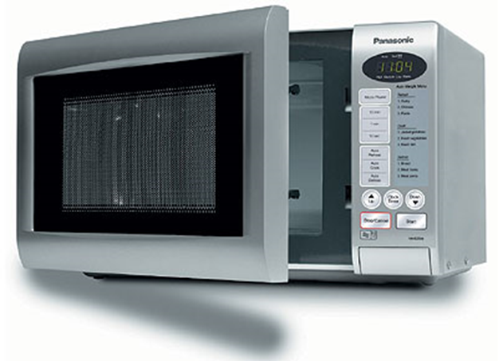

They are produced by special vacuum tubes (called klystrons, magnetrons and Gunn diodes).

Due to their short wavelengths, they are suitable for the radar systems used in aircraft navigation.

Infrared waves
Infrared waves are sometimes referred to as heat waves.

Infrared waves are produced by hot bodies and molecules.

Infrared radiation plays an important role in maintaining the earth’s warmth or average temperature through the greenhouse effect.

Infrared Waves
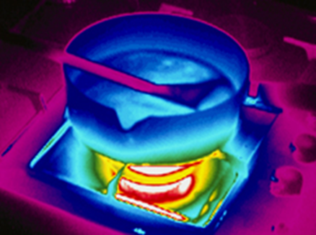

Infrared Waves
-Shorter wavelength than microwaves
-Higher frequency than microwaves, but lower than red light

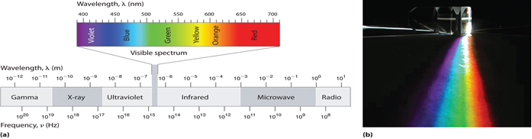

1) Infrared rays are used as a source of heat & to discover areas of heat difference.

2) You can’t see infrared radiation, but your skin feels its warmth

Visible rays
It is the part of the spectrum that is detected by the human eye.

It runs from about

4 × 10¹⁴ Hz to about 7 × 10¹⁴ Hz or a wavelength range of about 700 – 400 nm.

Visible light emitted or reflected from objects around us provides us information about the world.

Visible Light
-Each wavelength corresponds to a specific frequency
** Color determined by frequency

Ultraviolet rays
It covers wavelengths ranging from about 4 × 10^{–7} m (400 nm) down to 6 × 10^{–10} m (0.6 nm).

Ultraviolet (UV) radiation is produced by special lamps and very hot bodies.

The sun is an important source of ultraviolet light.

Ultraviolet radiations can be focused into very narrow beams for high precision applications such as LASIK (Laser assisted in situ keratomileusis) eye surgery.

Ultraviolet lamps are used to kill germs in water purifiers.

UV Rays
-Shorter wavelength and higher frequency than violet light
1) UV rays have applications in health and medicine, and in agriculture.
a) Helps skin produce Vit. D, can cause sunburn, cancer, and used to kill microorganisms

X-rays
It covers wavelengths from about 10^{‒8} m (10 nm) down to 10^{‒13} m (10^{‒4} nm).

One common way to generate X-rays is to bombard a metal target by high energy electrons.

X-rays are used as a diagnostic tool in medicine and as a treatment for certain forms of cancer.

X-Rays
-Shorter wavelength and higher frequency than UV rays
1) X-rays are used in medicine, industry, and transportation to make pictures of the inside of solid objects.
a) X-rays are absorbed by solid objects (teeth, bones) & so solid objects appear white

Gamma rays
The wavelengths of Gamma rays are from about 10^{‒10} m to less than 10^{‒14} m.

Gamma rays are produced in nuclear reactions and also emitted by radioactive nuclei.

They are used in medicine to destroy cancer cells.

Gamma Rays
-Shortest wavelength
-Highest frequency
1) Gamma rays are used in the medical field to kill cancer cells and to make pictures of the brain & in industrial situations as an inspection tool.

1. the bending of light is called refraction.
2. light bouncing off is called reflection
3. A transparent object is something that will allow all of the light rays to pass through it. Things like glass, some kids of plastic and food wrap are transparent because of the density of the molecules inside it.
A translucent object is a material that will only allow some or a little bit of the light rays to pass through it. Things like wax paper, cloth and paper are translucent because of the density of the molecules inside it.
An opaque object is something that will allow no light to pass through it because the density of the object is too great. Things like wood folders and mirrors are opaque.
The difference between transparent, translucent, and opaque objects is that opaque objects are denser in molecules than translucent objects and that translucent object are denser than transparent objects.

Transparent objects let all the light rays pass through.

Translucent objects are denser therefore allowing only some light rays to pass through because some are ether being absorbed or reflected.

Opaque objects don't allow any light rays to pass through because all of the light rays are being reflected or absorbed.

When a wave hits an uneven surface

As the normal drawn at various points on rough, uneven surface are not parallel, the angles of incidence of rays will differ and hence angle of reflection will also not be equal.
As a result although incident rays are parallel, the various rays after reflection, will not remain parallel.
This reflection is called diffused reflection .Diffused reflection cannot form image of object from whom incident rays are coming

Mirage
A mirage is a naturally-occurring optical phenomenon, in which light rays are bent to produce a displaced image of distant objects or the sky.

The word comes from the Latin mirari, meaning 'to be astonished'. This is the same root as for mirror. Like a mirror, a mirage shows images of things which are elsewhere.

The principal physical cause of a mirage, however, is refraction and not reflection.

Speed of light
299,792,458 meters per second in vacuum (exactly)
299,704,600 meters per second in air
224,900,000 meters per second in water

If the wavelength is increased 10 times, the frequency decreases by 10 times, the speed of the wave (velocity is the better word) remains same.

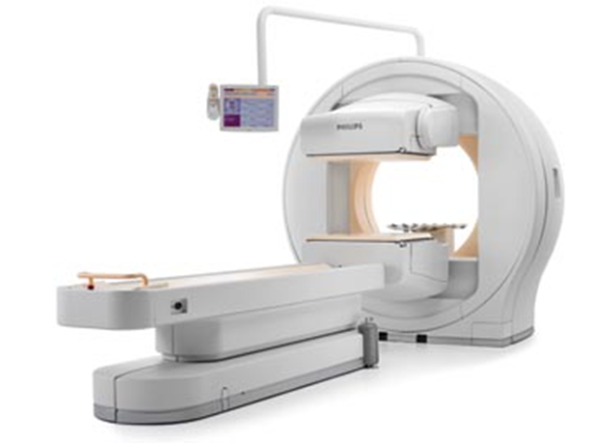

Absorption of Light
- Atoms can also absorb light shined on them.
- Any light not absorbed by the atoms in an object is scattered (reflected) back.
- If only some colors are absorbed, the rest are scattered back.
- We see the colors scattered back.
- White objects don’t absorb any light, all colors reflected.
- Black objects absorb most colors, little light reflected.
- Transparent objects let most light pass through without being absorbed or scattered.

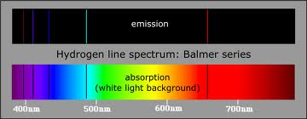

Atomic Emission Spectra
- Each element emits (gives off) its own, individual set of colors when energized.
- This is called its atomic emission spectrum.
- The colors show up as a series of lines when viewed through a prism.
- Like a fingerprint for that element.
- Used in astronomy to determine the composition of stars.
- Around 60 elements have been identified in our sun.
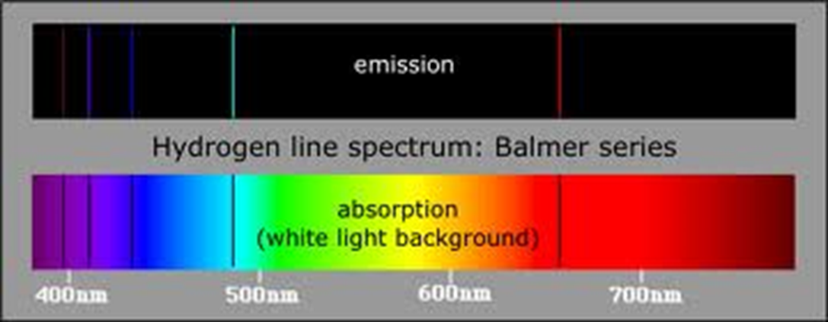

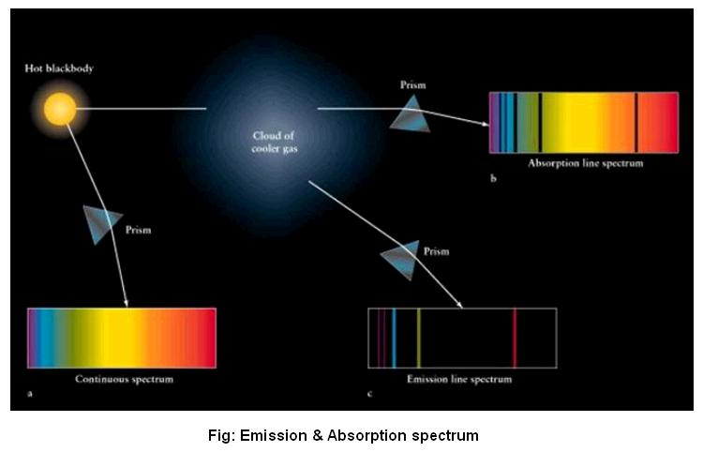

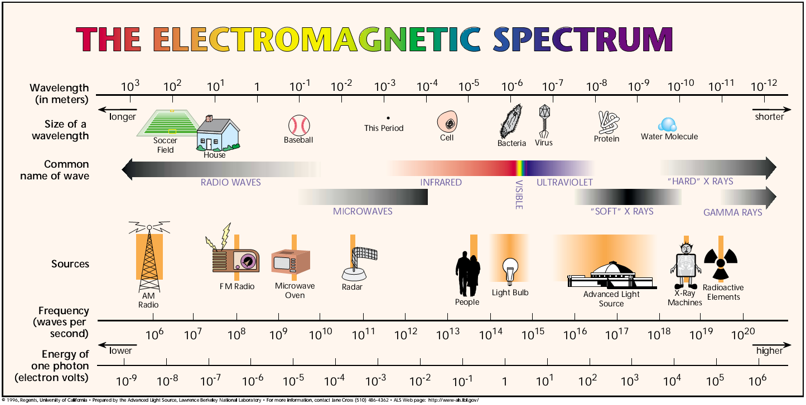

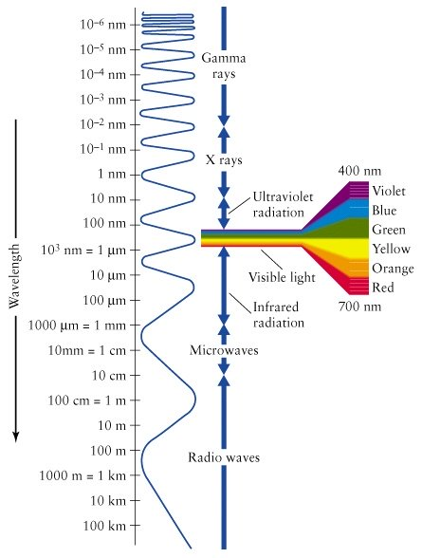

AM and FM
http://www.cybercollege.com/frtv/frtv017.htm

