NOTES ON

MAGNETISM

A SUBSTANCE THAT ATTRACTS IRON IS CALLED A MAGNET.

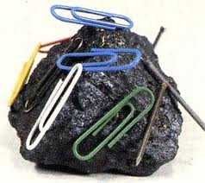

MORE THAN 2000 YEARS AGO THE GREEKS DISCOVERED THAT A CERTAIN ROCK WAS ATTRACTED TOWARD MATERIAL THAT CONTAINED IRON.

THIS ROCK WAS NAMED MAGNETITE, FOUND IN A REGION OF THE WORLD CALLED MAGNESIA.

Show this
https://www.youtube.com/watch?v=bBKYZFtcWHc

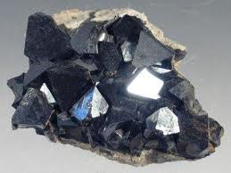

THE CHINESE DISCOVERED THAT IF AN IRON NEEDLE WAS RUBBED AGAINST THIS STONE, THE NEEDLE ALSO ATTRACTED BITS OF IRON. WHEN THIS NEEDLE WAS BALANCED, IT ALWAYS POINTED NORTH.

THE NEEDLE DIRECTED SAILORS ON THEIR VOYAGE. THIS MAGIC STONE WAS CALLED LODESTONE, WHICH MEANS LEADING STONE. THIS STONE IS A COMPOUND OF IRON-OXIDE (Fe₃O₄).

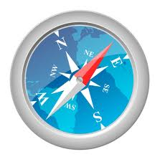

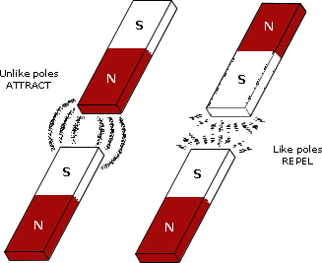

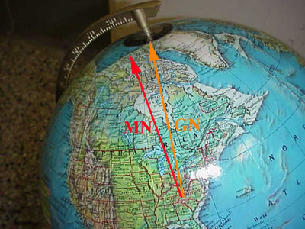

THE MAGNETIC POLES WANDER A BIT YEAR TO YEAR. IT IS BELIEVED THAT THE MAGNETIC POLES HAVE SWITCHED MANY TIMES DURING THE HISTORY OF THE EARTH.

AS LAVA COMES UP OUT OF THE CRACKS IT COOLS AND THE IRON IN IT MAINTAINS THE MAGNETIC ORIENTATION OF THE EARTH'S MAGNETIC FIELD AT THE TIME. THE ROCKS ON THE SEA FLOOR SHOW STRIPES OF MAGNETISM WITH NORTH AND SOUTH CHANGING POSITION. THIS WON'T BE AN ISSUE IN OUR LIFETIMES, AS THE PROCESS IS VERY SLOW: THE MAGNETIC POLES LAST SWITCHED 730,000 YEARS AGO.
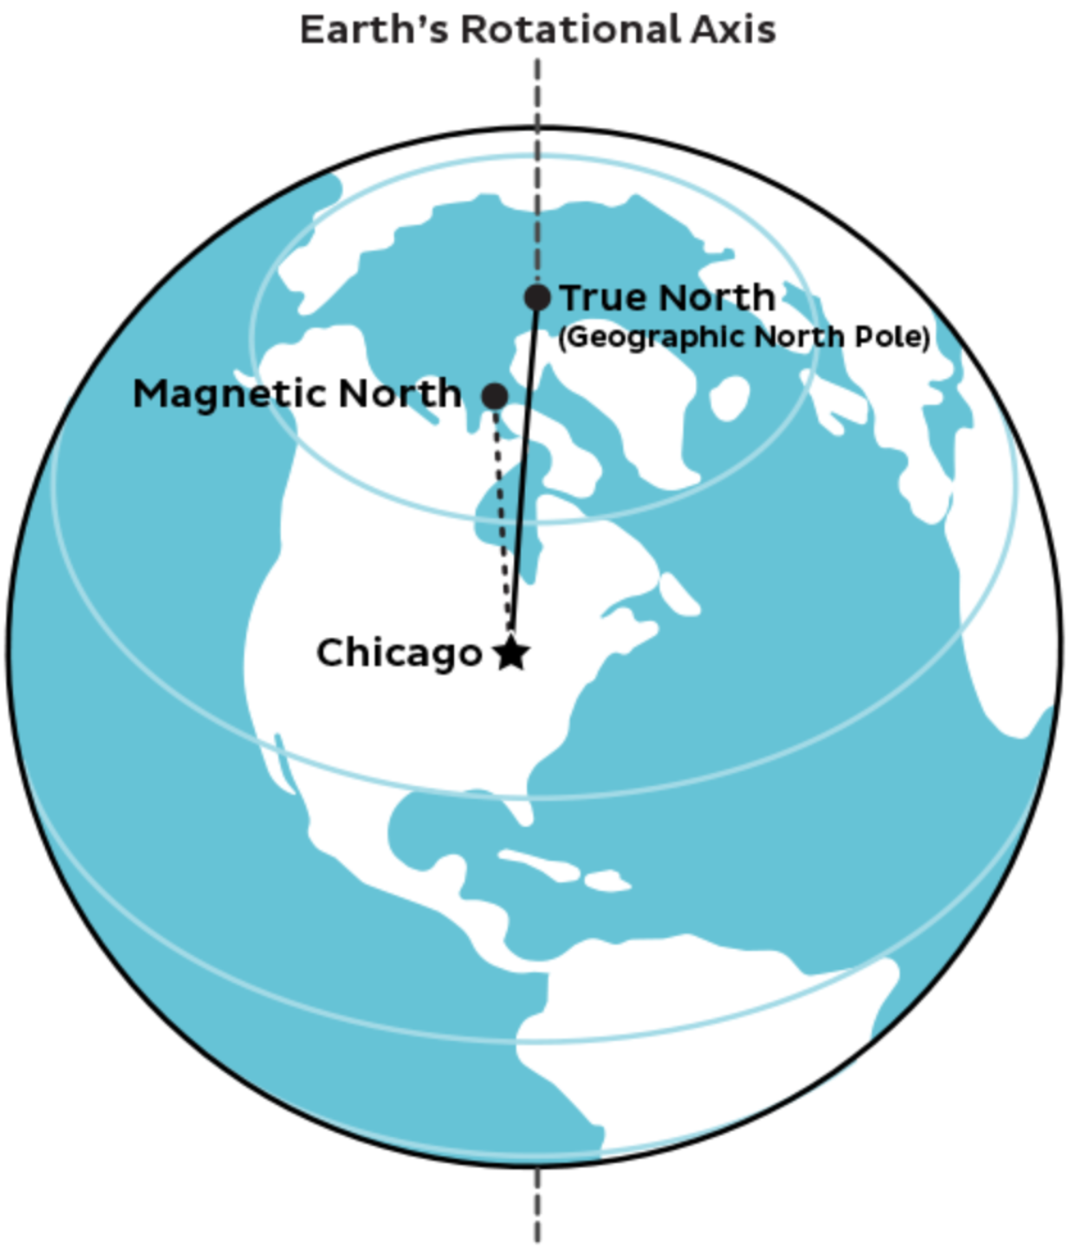
THE DIFFERENCE BETWEEN MAGNETIC NORTH AND GEOGRAPHIC NORTH IS IMPORTANT IF YOU ARE USING A COMPASS TO NAVIGATE. FOR US, THE DIFFERENCE WOULD THROW US OFF ONLY 1.5 DEGREES, WHICH IS ONLY SIGNIFICANT IF YOU ARE DOING PRECISE ORIENTEERING.

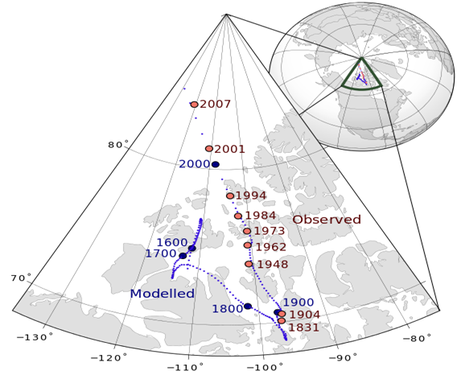

ONE END OF A MAGNET ALWAYS POINTS NORTH WHILE THE OTHER END POINTS SOUTH. WHEN A MAGNET IS ALLOWED TO TURN FREELY, THE TWO ENDS OF THE MAGNET THAT POINT NORTH-SOUTH ARE CALLED THE MAGNETIC POLES.

THE COMPASS LOOKS LIKE THE FACE OF A CLOCK. INSTEAD OF BEING DIVIDED INTO MINUTES, THE COMPASS IS DIVIDED INTO DIRECTIONS. THESE DIRECTIONS ARE CALLED THE POINTS OF THE COMPASS. ONE POINT IS NORTH. THE OPPOSITE IS SOUTH. THE RED END POINTS TO NORTH, AND THE WHITE END TO THE SOUTH.

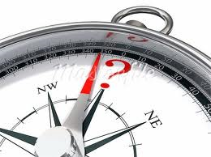

OBJECT THAT ARE ATTRACTED BY A MAGNET ARE SAID TO BE MAGNETIC.

IN SUBSTANCES THAT ARE MAGNETIZED, ALL OF THE MAGNETIC FIELDS ARE ORIENTED IN THE SAME DIRECTION.

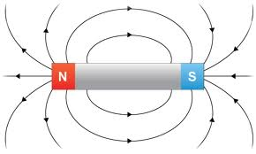

ALL OTHERS ARE NON-MAGNETIC.

IN A SUBSTANCE THAT IS NON-MAGNETIZED ALL OF THE MAGNETIC FIELDS ARE NOT ORIENTED IN THE SAME DIRECTION.

WHICH OF THE FOLLOWING OBJECTS ARE MAGNETIC?

- COPPER PENNY -
- SILVER DIME -
- BRASS SCREW
- IRON NAIL
- PAPER
- WOOD
- NICKEL
- GLASS
- ZINC
- COBALT
- GOLD
- LIQUID OXYGEN

Objects | My Hypothesis | Actual Fact

WHERE IS A MAGNET’S GREATEST STRENGTH?

A MAGNET HAS ITS GREATEST STRENGTH AT THE ENDS/POLES.

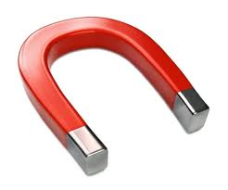

IT HAS LITTLE OR NO STRENGTH IN THE MIDDLE. THE ENDS OF THE MAGNET WHERE MAGNETIC STRENGTH IS
GREATEST ARE CALLED THE POLES. EVERY MAGNET HAS TWO POLES.

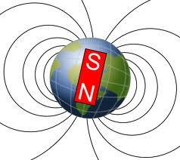

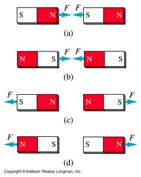
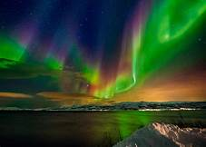

THE REGION AROUND A MAGNET WHERE THE MAGNETIC FORCE ACTS IS CALLED A MAGNETIC FIELD.

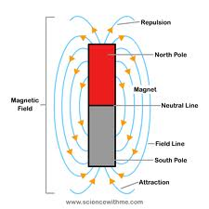

THE LAW OF MAGNETS

IF THE NORTH POLES OF TWO COMPASSES OR MAGNETS ARE PLACED NEAR EACH OTHER, THEY WILL REPEL (PUSH EACH OTHER AWAY) EACH OTHER.

THE SAME IS TRUE FOR THE SOUTH POLES. ON THE OTHER HAND, THE NORTH POLE OF ONE COMPASS NEEDLE WILL ATTRACK THE SOUTH POLE OF ANOTHER COMPASS NEEDLE. THIS IS KNOWN AS THE LAW OF MAGNETS.

THE LAW OF MAGNETS STATES THAT LIKE POLES REPEL EACH OTHER AND UNLIKE POLES ATTRACT EACH OTHER.

MAGNETIC FORCE

THE FORCE OF A MAGNET DEPENDS UPON ITS DISTANCE FROM A MAGNETIZED OBJECT. AS THE DISTANCE BETWEEN TWO MAGNETS BECOMES GREATER, THE MAGNETIC FORCE BECOMES WEAKER.

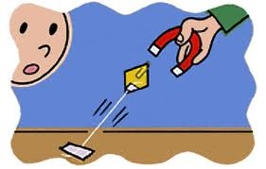

AS THE DISTANCE BETWEEN TWO MAGNETS BECOMES SMALLER, THE MAGNETIC FORCE BECOMES STRONGER.

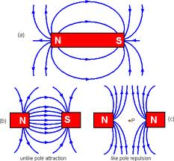

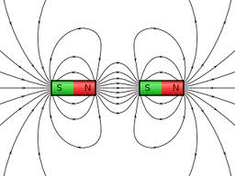

THE DOMAIN THEORY

SCIENTISTS BELIEVE THAT IF YOU CUT A PIECE OF STEEL DOWN TO ATOMS, YOU WOULD FIND THAT EACH ATOM IS A MAGNET. THE MAGNETIC ATOMS FORM LITTLE GROUPS CALLED DOMAINS.

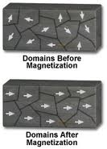

EACH DOMAIN HAS ITS OWN NORTH AND SOUTH POLES. REMEMBER, IN A PIECE OF UNMAGNETIZED IRON OR STEEL THE DOMAINS ARE NOT ARRANGED IN ANY DEFINITE ORDER.

IN THE MAGNETIZED OBJECT THE DOMAINS ARE ARRANGED IN A DEFINITE ORDER. THE NORTH POLES OF THE DOMAIN ALL POINT IN ONE DIRECTION. THE SOUTH POLES ALL POINT IN OPPOSITE DIRECTION.

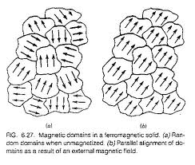

CAN A MAGNET LOSE ITS MAGNETISM?

HEATING A SUBSTANCE MAKES THE ATOMS IN THE SUBSTANCE MOVE FASTER.

HEATING A MAGNET BREAKS UP THE ORDERLY ARRANGEMENT OF THE DOMAINS.

DROPPING A MAGNET MAY ALSO BREAK UP THE ORDER OF THE DOMAINS. IF A MAGNET IS DROPPED A FEW TIMES IT WILL LOSE MOST OF ITS MAGNETISM. WHEN AN OBJECT LOSES ITS MAGNETISM, WE SAY IT IS DEMAGNETIZED.

HAMMERING THE MAGNET DOES THE SAME THING.

HEATING A MAGNET, DROPPING A MAGNET, AND HAMMERING A MAGNET CAUSE THE MAGNET TO BE DEMAGNETIZED.

MAGNETIC FIELDS

THE SPACE AROUND A MAGNET IS CALLED A MAGNETIC FIELD.

1

MAGNETIC FIELD BETWEEN TWO UNLIKE POLES.

MAGNETIC FIELD BETWEEN TWO LIKE POLES.

THE LINES ARE CALLED LINES OF FORCE.

IF THERE ARE MANY LINES OF FORCE AND THEY ARE CLOSE TOGETHER, THIS MEANS THAT THE MAGNETIC FORCE AT THIS POINT IS VERY STRONG.

SAILORS AND AIRPLANE PILOTS USE COMPASSES TO FIND OUT IN WHICH DIRECTION THEY ARE TRAVELLING. THESE MAPS SHOW IN WHICH DIRECTION A COMPASS NEEDLE WOULD POINT FROM VARIOUS SPOTS IN THE UNITED STATES.

MAGNETISM IN SPACE

THE MAGNETIC FIELD OF THE EARTH GOES INTO SPACE FOR HUNDREDS OF MILES. THE SUN ALSO HAS A MAGNETIC FIELD, ALONG WITH SOME OF THE PLANETS.

MAGNETIC FIELDS

THE EARTH AS A MAGNET

THE EARTH EXERTS MAGNETIC FORCES ON MAGNETS AND COMPASSES AND IS SURROUNDED BY A MAGNETIC FIELD THAT IS STRONGEST NEAR THE NORTH AND SOUTH MAGNETIC POLES. THE REGION OF THE EARTH’S MAGNETIC FIELD IS CALLED THE MAGNETOSPHERE.

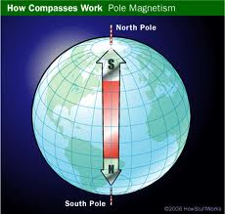

THE REGION IN WHICH MAGNETIC FORCES CAN ACT IS CALLED A MAGNETIC FIELD.

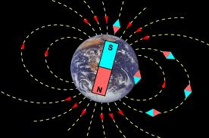

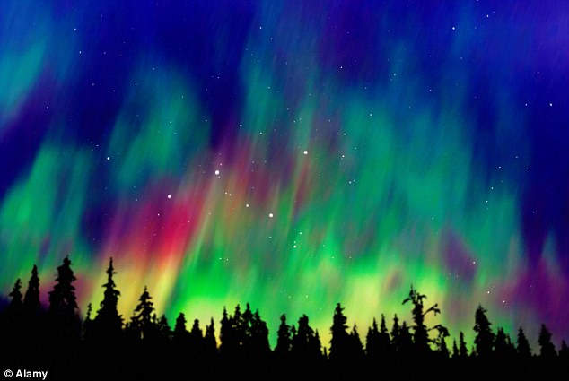

THERE ARE THREE TYPES OF MAGNETS:

NATURAL MAGNETS

THESE ARE NATURALLY OCCURING SUBSTANCES THAT HAVE MAGNETIC PROPERTIES-MAGNETITE.

SOME MATERIALS CAN BE MADE INTO MAGNETS BY STROKING THEM IN THE SAME DIRECTION SEVERAL TIMES WITH STRONG MAGNETS.

THE PROCESS BY WHICH A MATERIAL IS MADE INTO A MAGNET IS KNOWN AS MAGNETIC INDUCTION. EX. STROKE AN IRON NAIL IN THE SAME DIRECTION SEVERAL TIMES WITH A STRONG MAGNET.

TEMPORARY MAGNETS

MATERIALS SUCH AS SOFT IRON CAN BE EASILY MAGNETIZED. THESE MAGNETS ARE TEMPORARY
MAGNETS. THEY LOSE THEIR MAGNETISM QUICKLY.

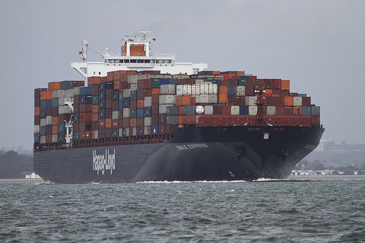

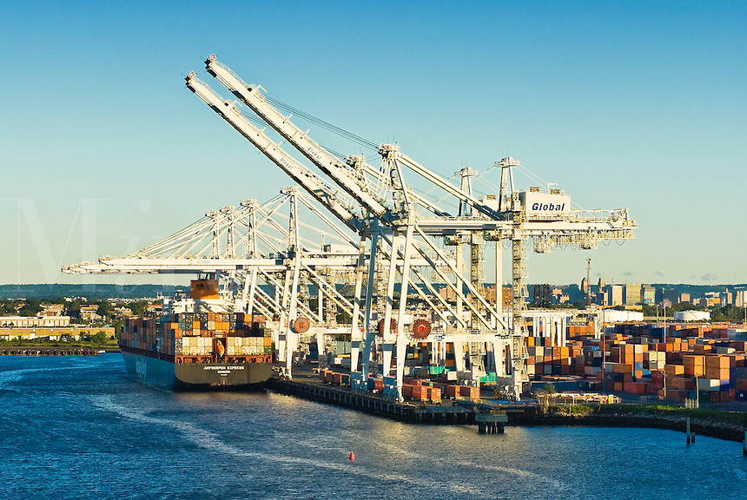
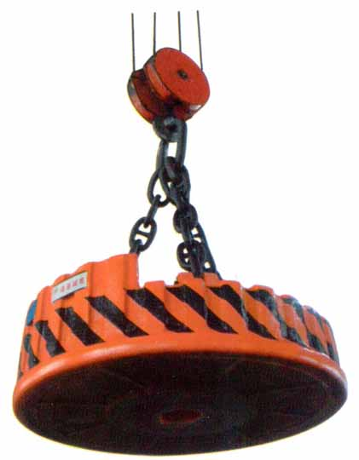

PERMANENT MAGNETS.

MAGNETS MADE OF MATERIALS THAT ARE DIFFICULT TO MAGNETIZE TEND TO STAY MAGNETIZED. THESE ARE PERMANENT MAGNETS. EX. COBALT, NICKEL, AND IRON.

MOST PERMANENT MAGNETS ARE MADE OF A MIXTURE OF ALUMINUM, NICKEL, COBALT, AND IRON. THIS MIXTURE IS CALLED ALNICo, AND MAKES VERY STRONG MAGNETS.

ELECTROMAGNETISM

https://www.youtube.com/watch?v=s94suB5uLWw

ELECTROMAGNETS ARE PRODUCED BY PASSING AN ELECTRIC CURRENT THROUGH A COIL OF WIRE WRAPPED AROUND A SOFT IRON CORE.

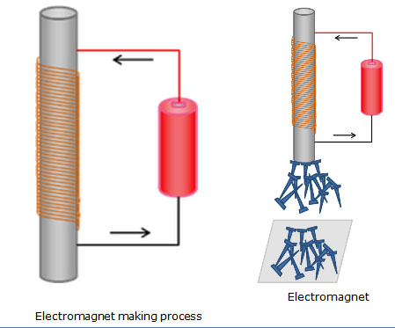

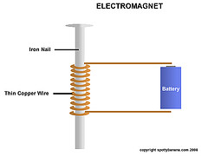

A DANISH PHYSICIST NAMED HANS CHRISTIAN OERSTED IN 1820 WAS LECTURING A PHYSICS CLASS WHEN HE NOTICED A WIRE LYING ABOVE A COMPASS.

HE OBSERVED THAT WHEN CURRENT FLOWED THROUGH THE WIRE, THE COMPASS NEEDLE TURNED 90 DEGREES. WHEN THE DIRECTION OF THE CURRENT WAS REVERSED, THE NEEDLE MOVED 90 DEGREES IN THE OPPOSITE DIRECTION. WHEN NO ELECTRICITY FLOWED THROUGH THE WIRE, THE COMPASS NEEDLE REMAINED STATIONARY.

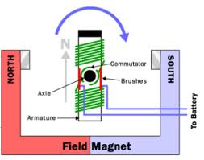

A LOOPED OR COILED WIRE ACTED LIKE A MAGNET WHEN CURRENT PASSES THROUGH IT. THE MORE COILS THE WIRE HAS, THE STRONGER THE MAGNET.

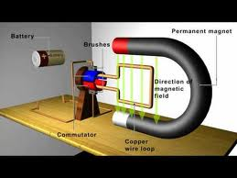

Show this one
https://www.youtube.com/watch?v=XiHVe8U5PhU

show both
https://www.youtube.com/watch?v=d_aTC0iKO68
https://www.youtube.com/watch?v=wxG3cwugXgs

https://www.youtube.com/watch?v=gQyamjPrw-U

Electric Motor
https://www.youtube.com/watch?v=Z9G3kKN1S1M
https://www.youtube.com/watch?v=Ylgb8FFMgd4

Electric Potential
https://www.youtube.com/watch?v=-Rb9guSEeVE

https://www.youtube.com/watch?v=KGTZPTnZBFE

https://www.youtube.com/watch?v=dFT7-_s0jh0

Very good Summary
https://www.youtube.com/watch?v=bht9AJ1eNYc

THE RELATIONSHIP BETWEEN ELECTRICITY AND MAGNETISM IS CALLED ELECTROMAGNETISM.

WRAPPING A COIL OF WIRE AROUND A SOFT IRON CORE AND PASSING AN ELECTRIC CURRENT THROUGH THE WIRE CAN MAKE ELECTROMAGNETS.

THE STRENGTH OF AN ELECTROMAGNET CAN BE INCREASED BY THE NUMBER OF LOOPS OF WIRE AROUND THE IRON CORE.

INCREASING THE CURRENT OR VOLTAGE WOULD INCREASE THE STRENGTH OF THE ELECTROMAGNET.

AN IMPORTANT PROPERTY OF AN ELECTROMAGNET IS THAT IT CAN BE MADE TO LOSE AND THEN REGAIN ITS MAGNETIC PROPERTIES BY TURNING THE CURRENT ON OR OFF.

QUES. HOW DOES A CRANE OPERATORS RELEASE AN OBJECT THAT IS HELD BY AN ELECTROMAGNET?

ANS. BY TURNING OFF THE CURRENT TO THE MAGNET.

ELECTROMAGNETIC INDUCTION

IF MAGNETISM CAN BE PRODUCED FROM ELECTRICITY, CAN ELECTRICITY BE PRODUCED FROM MAGNETISM?

THE ENGLISH SCIENTIST MICHAEL FARADAY DISCOVERED THAT AN ELECTRIC CURRENT COULD BE GENERATED, OR INDUCED, BY MOVING A WIRE THROUGH A MAGNETIC FIELD. THE PROCESS BY WHICH A CURRENT IS PRODUCED BY THE MOTION OF A CONDUCTOR (WIRE) IN A MAGNETIC FIELD IS CALLED ELECTROMAGNETIC INDUCTION.

WHEN A CONDUCTING WIRE CUTS ACROSS MAGNETIC LINES OF FORCE, ELECTRONS FLOW THROUGH THE WIRE AND A CURRENT IS PRODUCED.

TRANSFORMERS

A TRANSFORMER IS A UNIT THAT EITHER INCREASES OR DECREASES THE VOLTAGE OF ALTERNATING CURRENT.

A STEP-UP TRANSFORMER INCREASES VOLTAGE. A STEP-DOWN TRANSFORMER DECREASES VOLTAGE.
THE PROCESSES OF ELECTROMAGNETISM AND ELECTROMAGNETIC INDUCTION ARE COMBINED IN THE OPERATION OF A TRANSFORMER.

A TRANSFORMER CONSISTS OF TWO COILS OF INSULATED WIRE WRAPPED AROUND THE SAME IRON CORE. ONE COIL IS CALLED THE PRIMARY COIL AND THE SECOND IS CALLED THE SECONDARY COIL.

WHEN AN ALTERNATING CURRENT IS PASSED THROUGH THE PRIMARY COIL, A MAGNETIC FIELD IS CREATED.

ELECTROMAGNETIC INDUCTION CAUSES A CURRENT TO FLOW IN THE SECOND COIL. THIS IS BECAUSE THE SECONDARY COIL ACTS AS IF A MAGNET WERE SUDDENLY PUSHED INTO IT. MAGNETIC LINES OF FORCE ARE CUT, AND CURRENT IS INDUCED.

IF THE NUMBER OF LOOPS IN THE PRIMARY AND SECONDARY COILS ARE EQUAL, THE INDUCED VOLTAGE OF THE SECONDARY COIL WILL BE THE SAME AS THAT OF THE PRIMARY COIL.

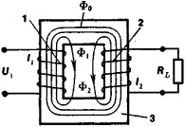

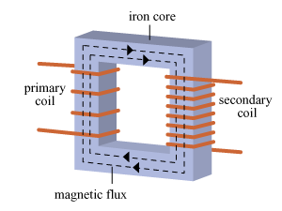

HOWEVER, IF THERE ARE MORE LOOPS IN
THE SECONDARY COIL THAN THE PRIMARY COIL, THE VOLTAGE OF THE SECONDARY COIL WILL BE GREATER. SINCE THIS TYPE OF TRANSFORMER INCREASES THE VOLTAGE, IT IS CALLED A STEP-UP TRANSFORMER.

IN A STEP-DOWN TRANSFORMER, THERE ARE FEWER LOOPS IN THE SECONDARY COIL THAN IN THE PRIMARY COIL. SO THE VOLTAGE OF THE SECONDARY COIL IS LESS THAN THAT OF THE PRIMARY COIL.

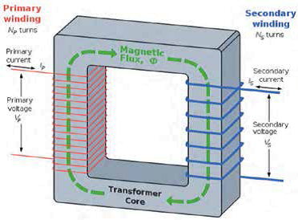

STEP-UP TRANSFORMERS ARE USED BY POWER COMPANIES TO TRANSMIT HIGH-VOLTAGE ELECTRICITY TO HOMES AND OFFICES.

STEP-DOWN TRANSFORMERS REDUCE THE VOLTAGE OF ELECTRICITY FROM A POWER PLANT SO THAT IT COULD BE USED IN HOMES. STEP-DOWN TRANSFORMERS ALSO ARE USED IN DOORBELLS, MODEL ELECTRIC TRAINS, SMALL RADIOS, TAPE PLAYERS AND CALCULATORS.

A STEP-DOWN TRANSFORMER IS USED BY POWER COMPANIES TO REDUCE HIGH-VOLTAGE ELECTRICITY TRANSMITTED FROM POWER PLANTS SO IT CAN BE USED IN HOMES AND OFFECES.

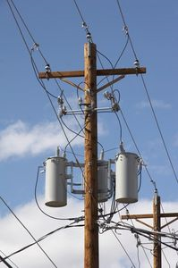

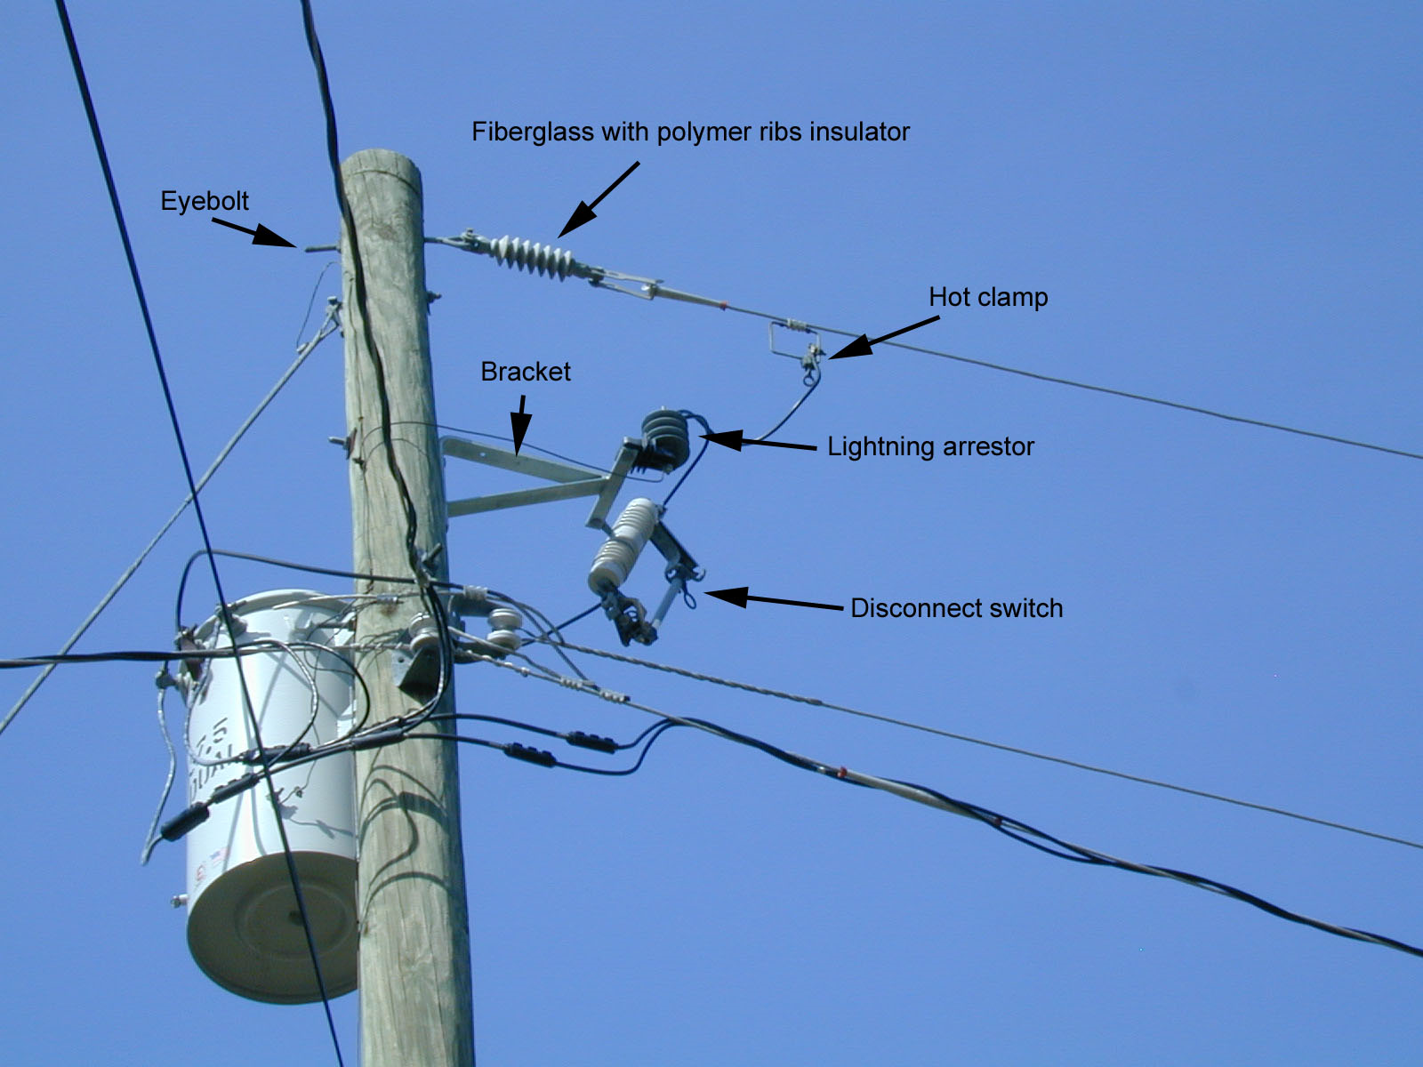

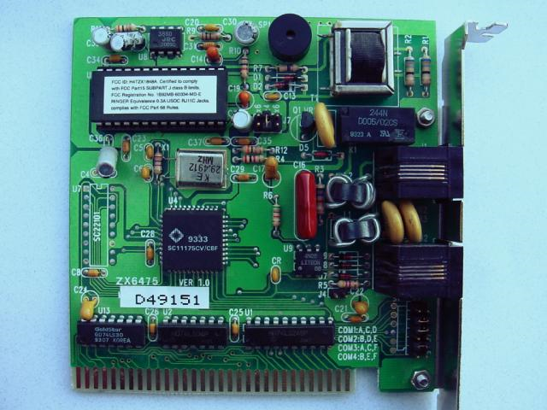

GENERATORS

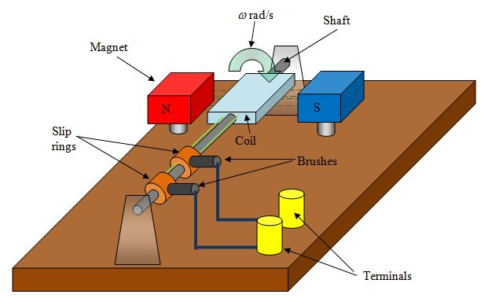

A GENERATOR IS A DEVICE THAT CONVERTS MECHANICAL ENERGY INTO ELECTRICAL ENERGY.

A GENERATOR CONSISTS OF AN INSULATED LOOP OF WIRE AND A U-SHAPED MAGNET THAT PRODUCES A MAGNETIC FIELD.

THE LOOP OF WIRE THAT IS ATTACHED TO A POWER SOURCE IS PLACED BETWEEN THE POLES OF THE
U-SHAPED MAGNET.

AS THE POWER SOURCE ROTATES THE LOOP OF WIRE CLOCKWISE, THE WIRE CUTS THE MAGNETIC LINES OF FORCE AND A CURRENT IS PRODUCED.

AS THE LOOP OF WIRE CONTINUES TO ROTATE, THE WIRE MOVES PARALLEL TO THE MAGNETIC LINES OF FORCE. AT THIS TIME NO LINES ARE BEING CUT SO NO CURRENT IS PRODUCES.

FURTHER ROTATION MOVES THE LOOP OF WIRE TO A PLACE WHERE MAGNETIC LINES OF FORCE ARE CUT ONCE AGAIN. THIS TIME THE LINES OF FORCE ARE CUT FROM THE OPPOSITE DIRECTION. THE INDUCED CURRENT IS IN THE OPPOSITE DIRECTION. SINCE THE DIRECTION OF ELECTRIC CURRENT PRODUCE CHANGES WITH EACH COMPLETE ROTATION OF THE WIRE, THE CURRENT PRODUCED IS AC OR ALTERNATING CURRENT.

BICYCLES WITH GENERATORS

TO TURN THE LIGHT ON, A KNOB ON THE GENERATOR IS MOVED SO THAT IT TOUCHES THE WHEEL. AS YOU PEDDLE THE BIKE, YOU ARE PROVIDING MECHANICAL ENERGY TO TURN THE WHEEL.

THE WHEEL THEN TURNS THE KNOB. THE KNOB IS ATTACHED TO A SHAFT INSIDE THE GENERATOR. THE SHAFT ROTATES A COIL OF WIRE THROUGH MAGNETIC LINES OF FORCE. THEN THE LIGHTS COME ON.

MOST OF THE ELECTRIC POWER WE USE TODAY COMES FROM GENERATORS. THE LARGE GENERATORS IN POWER PLANTS HAVE MANY LOOPS OF WIRE ROTATING INSIDE LARGE ELECTROMAGNETS.

IN THE OPERATION OF A GENERATOR, WATER SPINS A TURBINE (TURBINES ARE WHEELS THAT ARE TURNED BY THE FORCE OF MOVING WATER), WHICH IN TURN MOVES LARGE ELECTROMAGNETS ENCASED IN COILS OF INSULATING WIRE.

AS THE ELECTROMAGNETS MOVE, THE COILED WIRE CUTS MAGNETIC LINES OF FORCE. CURRENT IS PRODUCED IN THE WIRE AND CONDUCTED THROUGH POWER LINES THAT REACH HOMES AND OTHER BUILDINGS.

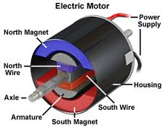

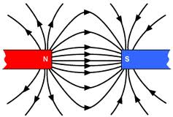

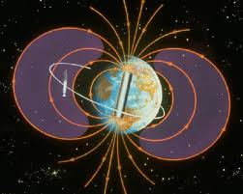

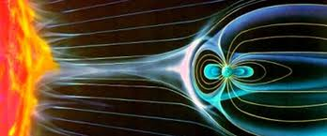

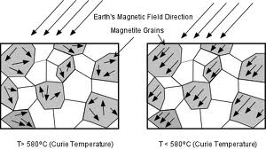

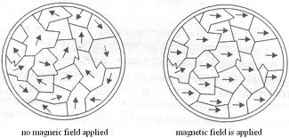

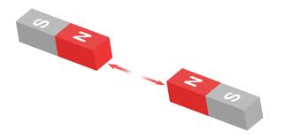

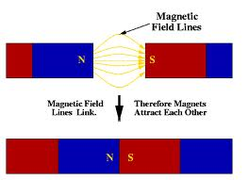

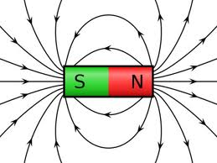

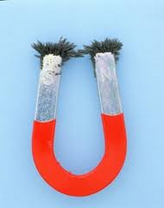

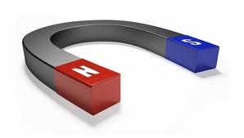

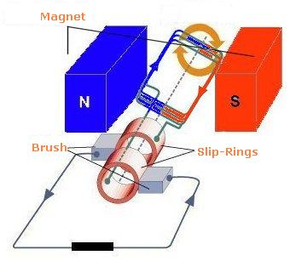

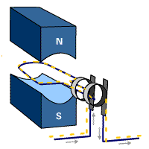
http://www.quarkology.com/12-physics/93-motors-generators/images/93D-anim-ac-generator.gif

A simple a.c. generator or alternator. It consists of a coil mounted on an axle between the poles of magnet. The ends of the coil are fixed to two copper slip rings which rotate with the coil. Two carbon brushes press against the slip rings connecting them to the outside circuit. When the coil is rotated, it causes an a.c. to flow through the circuit.

SLIP RINGS
A slip ring consists of a conductive circle or band mounted on a shaft and insulated from it. Electrical connections from the rotating part of the system, such as the rotor of a generator, are made to the ring. Fixed contacts or brushes run in contact with the ring, transferring electrical power or signals to the exterior, static part of the system.

One of the two rings is connected to one end of the armature winding and other one to the other end of the armature winding.

BRUSH

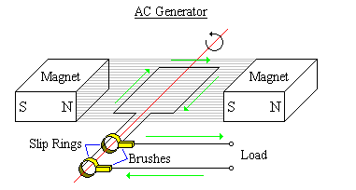

http://www.google.com/imgres?imgurl=http://www.creative-science.org.uk/projects/gen/gen1.jpg&imgrefurl=http://www.creative-science.org.uk/gen1.html&usg=__OKQnZ7WWibagL5YFS2VrnZvOz2s=&h=276&w=400&sz=37&hl=en&start=15&zoom=1&tbnid=SLAaAAsCxXydzM:&tbnh=86&tbnw=124&ei=eiFcUbjWJIv8rAeDhoDQAw&prev=/search%3Fq%3DA%2BSIMPLE%2BGENERATOR%26um%3D1%26hl%3Den%26safe%3Dactive%26client%3Dfirefox-a%26sa%3DN%26rls%3Dorg.mozilla:en-US:official%26tbm%3Disch&um=1&itbs=1&sa=X&ved=0CEgQrQMwDg

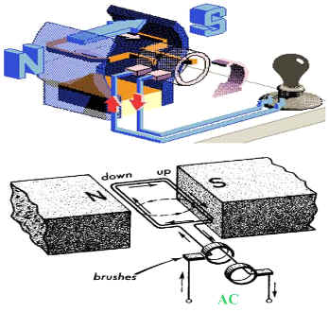

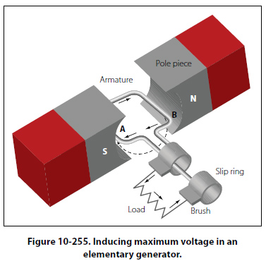

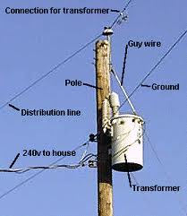

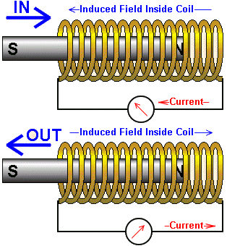

http://www.mcwdn.org/Physics/MagnetQuiz.html

http://www.proprofs.com/quiz-school/story.php?title=Magnetism-Quiz



https://en.wikipedia.org/wiki/Electromagnetism



