NOTES
SOUND
____________________________________

WHAT IS SOUND?
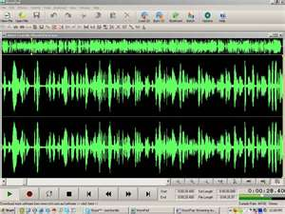

SOUND IS A LONGITUDINAL, MECHANICAL WAVE.
https://www.khanacademy.org/science/ap-physics-1/ap-mechanical-waves-and-sound/introduction-to-sound-waves-ap/v/sound-properties-amplitude-period-frequency-wavelength
https://www.khanacademy.org/science/ap-physics-1/ap-mechanical-waves-and-sound/introduction-to-sound-waves-ap/v/sound-properties-amplitude-period-frequency-wavelength
https://www.khanacademy.org/science/ap-physics-1/ap-mechanical-waves-and-sound/introduction-to-sound-waves-ap/v/production-of-sound
SOUND CAN TRAVEL THROUGH ANY MEDIUM, BUT IT CANNOT TRAVEL THROUGH A VACUUM. THERE IS NO SOUND IN OUTER SPACE.
SOUND IS A VARIATION IN PRESSURE.

A REGION OF INCREASED PRESSURE ON A SOUND WAVE IS CALLED A COMPRESSION.

A REGION OF DECREASED PRESSURE ON A SOUND WAVE IS CALLED A RAREFACTION.

LIKE ALL WAVES, SOUND WAVES CARRY ENERGY THROUGH A MEDIUM WITHOUT THE PARTICLES OF THE MEDIUM TRAVELING ALONG.

SOUND IS A DISTURBANCE THAT TRAVELS THROUGH A MEDIUM AS A LONGITUDINAL WAVE.

WHEN THE DISTURBANCE REACHES THE AIR NEAR YOUR EARS, YOU HEAR THE SOUND.

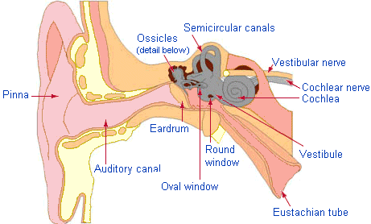

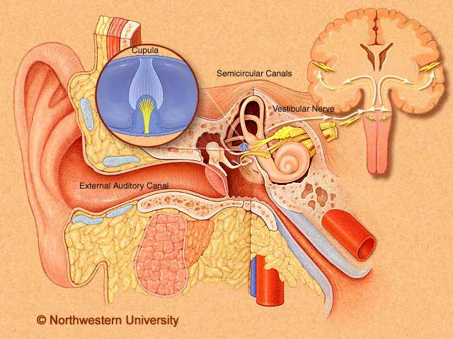

SEE P. 304

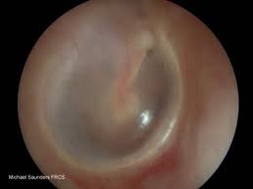

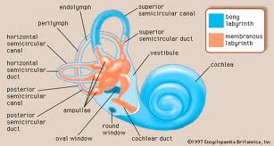

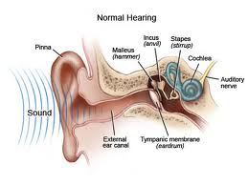

REMOVAL OF CERUMEN

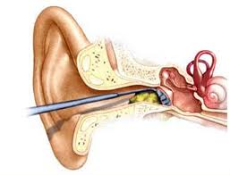

FOREIGN OBJECT IN EAR

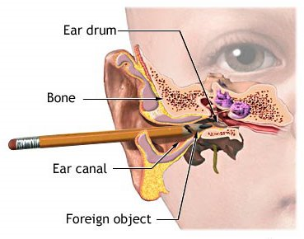

SOUNDS TRAVEL THROUGH, GASES, SOLIDS, AND LIQUIDS.

SOUND WAVES TRAVEL ONLY IF THERE IS A MEDIUM TO TRANSMIT THE COMPRESSIONS AND RAREFACTIONS.

IN OUTER SPACE THERE IS NO AIR MOLECULES TO COMPRESS OR RAREFY. SOUND DOES NOT TRAVEL THROUGH OUTER SPACE.
THE SPEED OF SOUND

THE SPEED OF SOUND DEPENDS ON THE PROPERTIES OF THE MEDIUM IT TRAVELS THROUGH.

AT ROOM TEMPERATURE, 20⁰C, SOUND TRAVELS AT ABOUT 342 m/s.

THE SPEED OF SOUND DEPENDS ON THE ELASTICITY, DENSITY, AND TEMPERATURE OF THE MEDIUM.

ELASTICITY



ELASTICITY IS THE ABILITY OF A MATERIAL TO BOUNCE BACK AFTER BEING DISTURBED.

IF A MEDIUM IS VERY ELASTIC, ITS PARTICLES EASILY GO BACK TO THEIR ORIGINAL POSITION.

SOUND TRAVELS MORE QUICKLY IN MEDIUMS THAT HAVE A HIGH DEGREE OF ELASTICITY BECAUSE WHEN THE PARTICLES ARE COMPRESSED, THEY QUICKLY SPREAD OUT AGAIN.

SOUND TRAVELS MORE SLOWLY IN DENSER MEDIUMS.

SOUND TRAVELS MORE SLOWLY IN DENSE METALS, SUCH AS LEAD OR SILVER, THAN IN IRON OR STEEL.

SOUND TRAVELS MORE SLOWLY AT LOWER TEMPERATURES AND FASTER AT HIGHER TEMPERATURES.

AT A LOW TEMPERATURE, THE PARTICLES OF A MEDIUM ARE MORE SLUGGISH. THEY ARE MORE DIFFICULT TO MOVE AND RETURN TO THEIR ORIGINAL POSITIONS MORE SLOWLY.
SOUND TRAVELS MORE SLOWLY AT HIGH ALTITUDES BECAUSE THE AIR IS VERY COLD.

PROPERTIES OF SOUND

THE PROPERTIES OF SOUND ARE:

A] INTENSITY
B] LOUDNESS
C] FREQUENCY
D] PITCH
E] RESONANCE

INTENSITY

THE INTENSITY OF A SOUND WAVE IS THE AMOUNT OF ENERGY THE WAVE CARRIES PER SECOND THROUGH A UNIT AREA. INTENSITY IS MEASURED IN WATTS PER SQUARE METERS [W/m²]

LOUDNESS

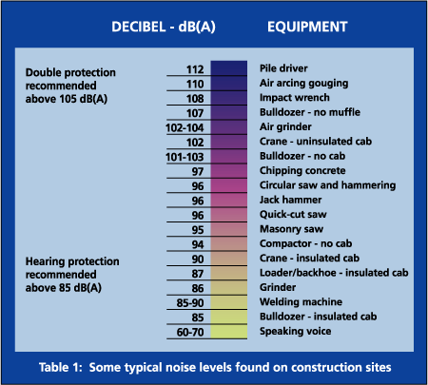
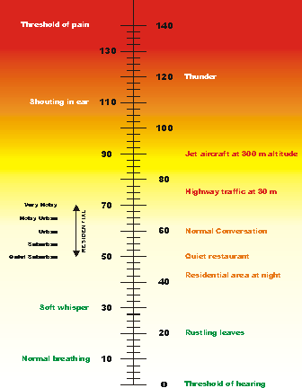

LOUDNESS IS THE PERCEPTION OF THE INTENSITY OF A SOUND.

SOUND WAVES OF HIGHER AMPLITUDE HAVE A GREATER INTENSITY BECAUSE THEY CARRY MORE ENERGY PER SECOND THROUGH A GIVEN AREA.

THE GREATER THE INTENSITY OF A SOUND WAVE, THE LOUDER IT IS. LOUDNESS DESCRIBES WHAT YOU ACTUALLY HEAR. A SOUND WAVE OF GREATER INTENSITY GENERALLY SOUNDS LOUDER.

LOUDNESS OR SOUND LEVEL, IS MEASURED IN DECIBELS [dB]

[LOUDNESS OF SOUNDS P. 505]

TO INCREASE THE LOUDNESS OF THE MUSIC COMING FROM A CD PLAYER, YOU ADJUST THE VOLUME.
LOUDSPEAKERS OR HEADPHONES GIVE OFF SOUNDS BY VIBRATING A CONE MATERIAL. THE VIBRATIONS MAKE COMPRESSIONS AND RAREFACTIONS IN THE AIR.

AS THE VOLUME IS TURNED UP, THE CONE VIBRATES WITH GREATER AMPLITUDE AND THE SOUND YOU HEAR IS LOUDER.

FREQUENCY

FREQUENCY IS THE NUMBER OF COMPLETED WAVES THAT PASS A GIVEN POINT IN A CERTAIN AMOUNT OF TIME.

MOST PEOPLE CAN HEAR SOUNDS WITH FREQUENCIES BETWEEN 20 Hz AND 20,000 Hz [OR 20 KHz]

SOUND WAVES WITH FREQUENCIES ABOVE THE NORMAL RANGE OF HEARING ARE CALLED ULTRASOUND.

SOUND WAVES WITH FREQUENCIES BELOW THE NORMAL HUMAN RANGE OF HEARING ARE CALLED INFRASOUND.

PITCH

THE FREQUENCY OF A SOUND WAVE IS CALLED PITCH.

THE PITCH OF A SOUND IS A DESCRIPTION OF HOW HIGH OR LOW THE SOUND SEEMS TO A PERSON.

SOUND WAVES OF HIGH FREQUENCY HAVE A HIGH PITCH, WHILE SOUND WAVES OF LOW FREQUENCY HAVE A LOW PITCH.

A TIGHT STRING ON A GUITAR/ VIOLIN PRODUCES A HIGHER FREQUENCY.

A SHORT STRING PRODUCES A HIGHER PITCH THAN A LONG STRING UNDER THE SAME TENSION.

THE KEYS FARTHEST TO THE LEFT ON A PIANO KEYBOARD PRODUCES NOTES WITH THE LOWEST PITCH.

IT IS ATTACHED TO THE LONGEST STRINGS WHICH VIBRATES AT A FREQUENCY OF 27 Hz.

THE KEYS FARTHEST TO THE RIGHT ON A PIANO KEYBOARD PRODUCES THE NOTES WITH THE HIGHEST PITCH. IT IS ATTACHED TO THE SHORTEST STRING, WHICH VIBRATES AT A FREQUENCY OF 4,186 Hz.

RESONANCE

RESONANCE IS THE INCREASE IN THE AMPLITUDE OF VIBRATION THAT OCCURS WHEN EXTERNAL VIBRATIONS MATCH THE OBJECTS’ NATURAL FREQUENCY.

THE SOURCES OF SOUNDS:
- VIBRATING SOLIDS
- RAPID EXPANSION OR COMPRESSION [EXPLOSIONS/IMPLOSITIONS]
- SMOOTH AIR FLOW AROUND BLUNT OBSTACLES
- WHISTLES
- MUSICAL INSTRUMENTS
- FLUTTERING VENETIAN BLINDS
- SINGING POWER LINES

THE DOPPLER EFFECT

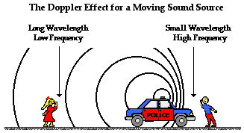

THE APPARENT CHANGE IN FREQUENCY AS A WAVE SOURCE MOVES IN RELATION TO THE LISTENER IS CALLED THE DOPPLER EFFECT.

AS A SOUND SOURCE MOVES TOWARDS THE LISTENER, THE WAVES REACH THE LISTENER WITH A HIGHER FREQUENCY. THE PITCH APPEARS TO INCREASE BECAUSE OF THE DOPPLER EFFECT.

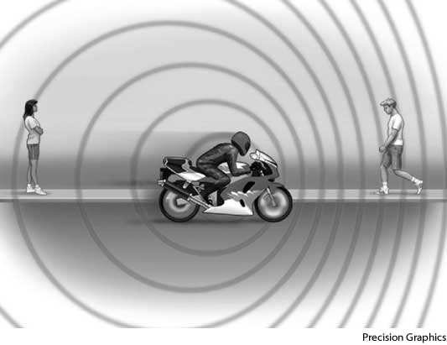

COMBINING SOUND WAVES

THE BLENDING OF THE FUNDAMENTAL TONES AND THE OVERTONES MAKE UP THE CHARACTERISTIC SOUND QUALITY, OR TIMBRE, OF A PARTICULAR SOUND.

MUSIC IS A SET OF TONES COMBINED IN WAYS THAT ARE PLEASING TO THE EAR.

STRINGS

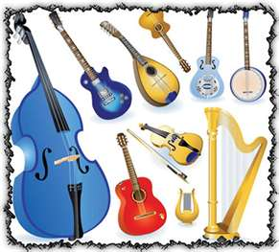

STRING INSTRUMENTS HAVE STRINGS THAT VIBRATE WHEN PLUCKED, STRUCK, OR RUBBED WITH A BOW.

A SHORT STRING VIBRATES AT A HIGHER FREQUENCY AND SO PRODUCES A HIGHER-PITCHED SOUND THAN A LONG STRING.

THE FINGERS ARE PLACED ALONG DIFFERENT PLACES ON THE STRING TO VARY THE PITCH.

BRASS

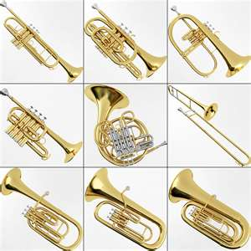

BRASS INSTRUMENTS PRODUCE SOUND WHEN THE PLAYER’S LIPS VIBRATE AGAINST THE MOUTHPIECE. THIS VIBRATION CAUSES THE AIR COLUMN INSIDE THE INSTRUMENT TO VIBRATE.

THE MUSICIAN ADJUSTS THE LENGTH OF THE AIR COLUMN BY PRESSING KEYS OR MOVING SLIDES. EX. TROMBONES & TRUMPETS

WOODWINDS

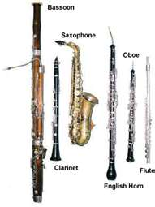

THESE INSTRUMENTS HAVE A REED. WHEN THE MUSICIAN BLOWS UNTO THE MOUTHPIECE, THE REED VIBRATES ALONG THE COLUMN OF AIR. THE LONGER THE COLUMN OF AIR, THE LOWER THE PITCH. EX. CLARINETS, OBOES, BASOON & TUBA.

PERCUSSION

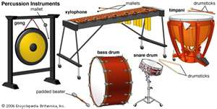

THESE INSTRUMENTS VIBRATES WHEN STRUCK. EX. DRUMS, BELLS, CYMBALS, & XYLOPHONES. LARGER DRUMS PRODUCE LOWER PITCHES.



